**Term work**

**on**

**OOPs with C++**

**(PCS 307)**

**2021-22**

**Submitted to: Submitted by:**

Akash Chauhan Prakhar Dhyani

Assistant Professor University Roll. No.: 2018551 GEHU, D.Dun Class Roll. No./Section: 41/B

**DEPARTMENT OF COMPUTER SCIENCE AND ENGINEERING**

**GRAPHIC ERA HILL UNIVERSITY, DEHRADUN**

**ACKNOWLEDGMENT**

I would like to particularly thank my Data Science using OOPs with C++ Lab Faculty **Mr. Akash Chauhan** for his patience, support and encouragement throughout the completion of this Term work.

At last but not the least I greatly indebted to all other persons who directly or indirectly helped me during this course.

Photo [optional]  **Prakhar Dhyani**

**<Paste your signature here>**

**University. Roll No.- 2018551**

**B.Tech CSE-B-III Sem**

**Session: 2021-22**

**GEHU, Dehradun**



Table of Contents

|  |  |  |
| --- | --- | --- |
| **Program No.** | **Program Name** | **Page No** |
| 1 | Run all four compilation units individually for any sample program using C++. |  |
| 2 | Write an Efficient code to check if a number is prime or not. |  |
| 3 | Write C++ code for below mentioned tasks?  **Task1:** How the preprocessor will react when you try to use, #include<iostream.h> instead of #include<iostream>?  **Task2:** How the preprocessor will react when you use cout but don't include #include<iostream> in your code?  **Task3:** Take a char variable and use cin to take its value from the user, cout it and it will only return one character and loss rest of the data you have entered!  **Task4:** How to resolve above issue? [Hint: by using, getline(cin, line);] |  |
| 4 | Write C++ code for below mentioned tasks?  **add(int,int), add(float, float), both of these methods are in two different namespaces First and Second respectively.**  **Task1:** Access these methods using scope resolution operator [::](SRO) from main method?  **Task2:** Access these methods using "using" keyword for main method?  **Task3:**  Try to access these methods without using, (SRO) and "using" keyword and check how the compiler will react to it?  **Task4:** Try to access these methods for Mixed Values [Int, Float] and see how the compiler will react to it? |  |
| 5 | Write C++ code for below mentioned tasks?  **Primary Data Types related questions in C++:**  **Task1:**Initialise all primary data types, assign their values and print them all? [char, bool, short, int, long, float, double, long double, wide char]  **Task2:** Apply sizeof operator on all above operators and their variables?        Example        Int a = 10;       Cout << Sizeof(int);       Cout << Sizeof(a); |  |
| 6 | Write C++ code for below mentioned tasks?  **String related Questions in C++:**  **Task1:**What happens if we add integer with a string, how the compiler would react to it?  String str = "ABC"; Int a = 1; String str2 = str + a;  **Task2:** Check the entered string is Palindrome or not?  String str = "75457" Output: Yes it is a palindrome or No it is not a Palindrome.  (Use, getline(sin, str1) and reverse_iterator of string to check this)  **Task3:** Make a reverse of a string using reverse method and reverse_iterator of string class?  **Task4:** String Compare: Check if the strings are equal or not? (do not use str1.compare(str2), do it manually)  **Task5:** String Compare: Check the possible values string.compare() function will return?              (Create cases in which compare function would return below values)  X>0 X<0 X==0 X = -4 X = 5 X = -2104040...  Also check the ASCII difference between two characters?(use int type cast)  **Task6:** Check if string is mutable in C++ or not? String a = "Hello"; Cout << &a; a[0] = 'J'; Cout << &a; Cout << a;  What is the output? |  |
| 7 | Write C++ code for below mentioned tasks?  **Array and 2D Array related Questions in C++:**  **Task1:** Create a switch statement [Manual], In Which:    a. When you pass 1 your program would print current year   b. When you pass 2 your program would print current month   c. When you pass 3 your program would print current day   d. When you pass 4 your program would print Not applicable  **Task2:** Create a switch statement [Using ctime], In Which:    a. When you pass 1 your program would print current year   b. When you pass 2 your program would print current month   c. When you pass 3 your program would print current day   d. When you pass 4 your program would print Not applicable    **Task3:**    v1. Print using reverse method:    1 2 3  9 8 7    4 5 6  ==>    6 5 4    7 8 9             3 2 1      v2. Print using (10- arr[i][j])  method:    1 2 3  9 8 7    4 5 6  ==>    6 5 4    7 8 9             3 2 1      v3. Restore using reverse method [without creating new array]:    1 2 3  9 8 7    4 5 6  ==>    6 5 4    7 8 9             3 2 1      v4. Restore using (10- arr[i][j]) method [without creating new array]:    1 2 3  9 8 7    4 5 6  ==>    6 5 4    7 8 9              3 2 1  **Task4:** Restore the same values in the same array, arr[3][3]:    1 2 3 1 1 1            4 5 6     ==> 2 2 2    7 8 9 3 3 3    v1. Use row loop [int i, for all j]    v2. Use arr[i][N-1]/3, at each place    v3. Use, arr[i][j]-(2*i+j)  **Task5:** Store these in an array[4][4] in given fassion and then print:  *  * *  * * *  * * * *  **Task6:** Store these in an array[4][4] in given fashion and then print:  * * * *  * * *  * *  *  **Task7:** Store these in an array[4][4] in given fashion and then print:  *          * *        * * *      * * * *    **Task8:** Store these in an array[4][4] in given fashion and then print:  * * * *  * * *  * *  * |  |
| 8 | Write C++ code for below mentioned tasks?  **Pointer, Function, Inline Function, Recursion in C++:**  **Task1:**Will the program through an error and if yes then why?  int *p = {10,20,20};  cout << *p;  p++;  cout << *p;  **Task2:**Output of this program?  **V1.** Issue?  int arr[] = {10,20,30};  cout << *arr;  cout << arr;  arr++;  cout << *arr;  **V2.**How to resolve above issue?  int arr[] = {10,20,30};  cout << *arr;  cout << arr;  cout << *(?);  **Task3:**Output of this program?  **V1.**Output?  int a = 10;  int *p;  int **q;  p = &a;  q = &p;  cou << *p;  cou << **q;  **V2.** Change the value of a using q pointer to pointer.  **Task4:** Find factorial of a number using function but not recurssion  **Task5:** Find factorial of a number using recurssion  **Task6:** Series Problem using recurssion for n series  2, (2^2 + 2), (3^3 + 3), (4^4 + 4), (5^5 + 5), .......  Hint:  n * ((n-1)^(n-1) + (n-1))  **Task7:** Perform Call by value, call by Address for swapping value of a and b:  int a = 10;  int b = 20;  **V1.**Swap(a,b); //call by Value [void swap(int a, int b){}]  **V2.**Swap(a,b); //call by Value [void swap(int &a, int &b){}]  **V3.**Swap(&a,&b); //call by Address |  |
| 9 | Write C++ code for below mentioned tasks?  **Class, Object, Constructor, Static Data Members, friend function in C++:**  **Task1: Class and Object in C++** a. WAP to assign and print the roll number, phone number and address of two students having names "Sam" and "John" respectively by creating two objects of the class 'Student'. b. WAP which would contain array of objects [many objects], of a class Student. Student [Name, Age, Year, section, marks], the section would be A,B,C and D. Your program would be able to return the total marks of students in the college. Hint [Make a Matrix or Tabular diagram to understand the problem], all the rows will differ each other by different objects of Student class [Student s1,s2,s3,s4].  **Task2: Constructor in C++** WAP to create a class to print the area of a square and a rectangle. The class has two functions with the same name but different number of parameters. The function for printing the area of rectangle has two parameters which are its length and breadth respectively while the other function for printing the area of square has one parameter which is the side of the square. Use multiple constructors to for the initialization.  **Task3: Static Data Members in C++** WAP to count the total number of calls for a member function from more than one objects. [Lets say, from 3 such Objects]  **Task4: Friend Function in C++** WAP in which you create a Student class having basic information for each student, like name, age and marks. By using friend function add marks of all the students [lets say 3 objects] and print it.  **Task5: Structure in C++** WAP to create a College class and Student Structure in C++ in one program. By providing such suitable examples write at least 5 differences between class and struct code your have written above.  Hint [Access Specifiers, Heap and Stack, large and small memory, etc.]  **Task6: Extra Questions:** WAP which would perform these tasks of your data: a. Come to next line b. set minimum field width c. fill string with (*) after setw(15) function     **********1234 by using endl, setw, and setfill [Manipulators in C++] |  |
| 10 | Write C++ code for below mentioned tasks?  **Array of Objects, Pointer to Object, This pointer, Operator Overloading in C++**  **Task1: Array of Objects in C++** WAP to create a directory that contains the following information. (a) Name of a person (b) Address (c) Telephone Number (if available with STD code) (d) Mobile Number (if available) (e) Head of the family  **Task2: Pointer to Object in C++** WAP to create print or display Student information containing in Student class by using pointers to object.  **Task3: This pointer in C++** WAP to pass two variables in a parameterized constructor during object creation and have same names variables as class member data and constructor parameters. Your job is to calculate the remainder of those two numbers.  **Task4: Operator Overloading in C++** a). WAP, in which you write a friend function to overload a less than '<' operator in C++. b). WAP in which you can add two objects [every object would have 1 integer value] by overloading + operator, which eventually would add the data values of those two object by adding the objects. |  |



**DEPARTMENT OF CSE**

|  |
| --- |
| Photograph  Passport Size |

**B.Tech. CSE**

**STUDENT LAB REPORT SHEET**

**Name of Student ……………………………………….…….Mob.No……………………………….…………..**

**Address Permanent ………………………………………………………………………………………….………..**

**Father’s Name …………………………Occupation ……………………………MoNo……..…….….………**

**Mother’s Name ………………… …..Occupation……………………………MoNo…………….…………..**

**Section …………….Branch……………………Semester……………..Class Roll No………………. Grade A B C**

**Local Address…………………………………………………Email……………….……………………. Marks 5 3 1**

|  |  |  |  |  |  |  |  |  |
| --- | --- | --- | --- | --- | --- | --- | --- | --- |
| **S.No.** | **Practical** | **D.O.P.** | **Date of Submission** | **Grade (Viva)** | **Grade (Report File)** | **Total Marks (out of 10)** | **Student’s Signature** | **Teacher’s Signature** |
| **1** | **Practical-01** |  |  |  |  |  |  |  |
| **2** | **Practical-02** |  |  |  |  |  |  |  |
| **3** | **Practical-03** |  |  |  |  |  |  |  |
| **4** | **Practical-04** |  |  |  |  |  |  |  |
| **5** | **Practical-05** |  |  |  |  |  |  |  |
| **6** | **Practical-06** |  |  |  |  |  |  |  |
| **7** | **Practical-07** |  |  |  |  |  |  |  |
| **8** | **Practical-08** |  |  |  |  |  |  |  |
| **9** | **Practical-09** |  |  |  |  |  |  |  |
| **10** | **Practical-10** |  |  |  |  |  |  |  |
| **11** |  |  |  |  |  |  |  |  |
| **12** |  |  |  |  |  |  |  |  |

**Program 1**

**Source Code:**

**#include<iostream>**

**#define MAX 1000**

**using namespace std;**

**int main()**

**{**

**cout<<"Hello Word"<< MAX;**

**}**

**Output**

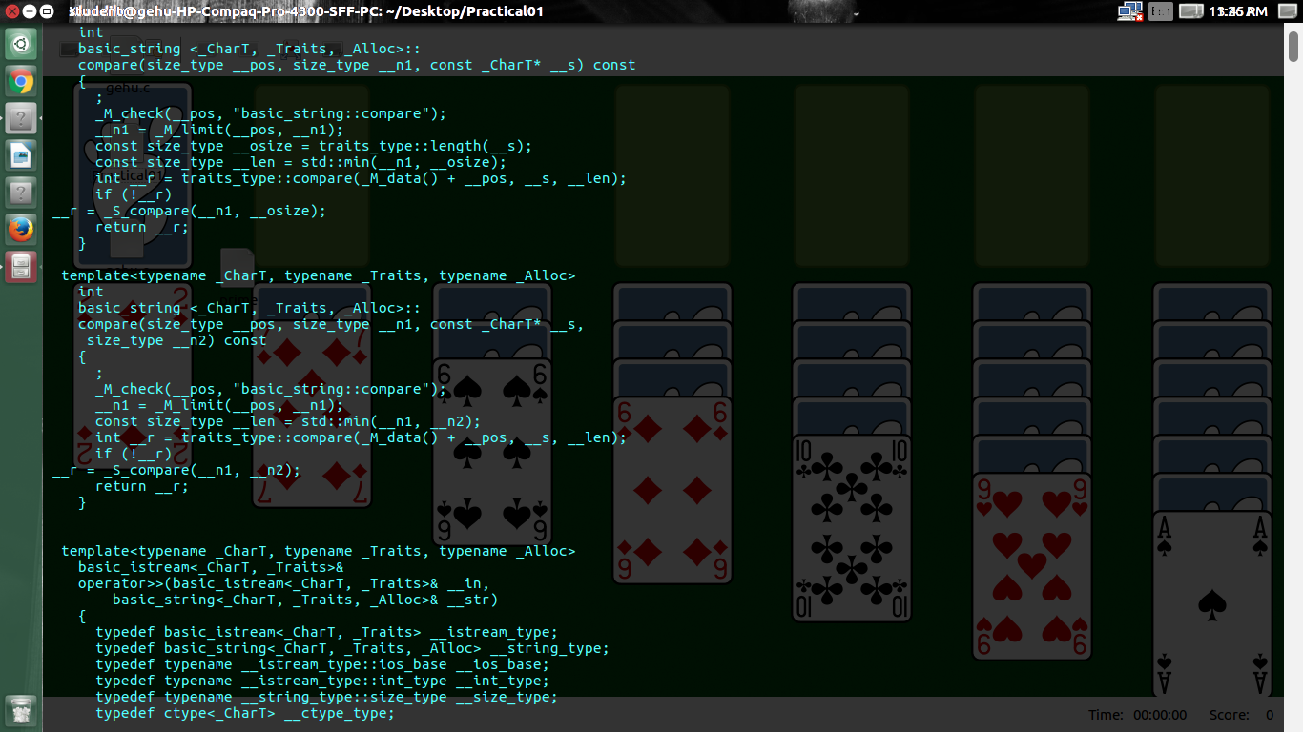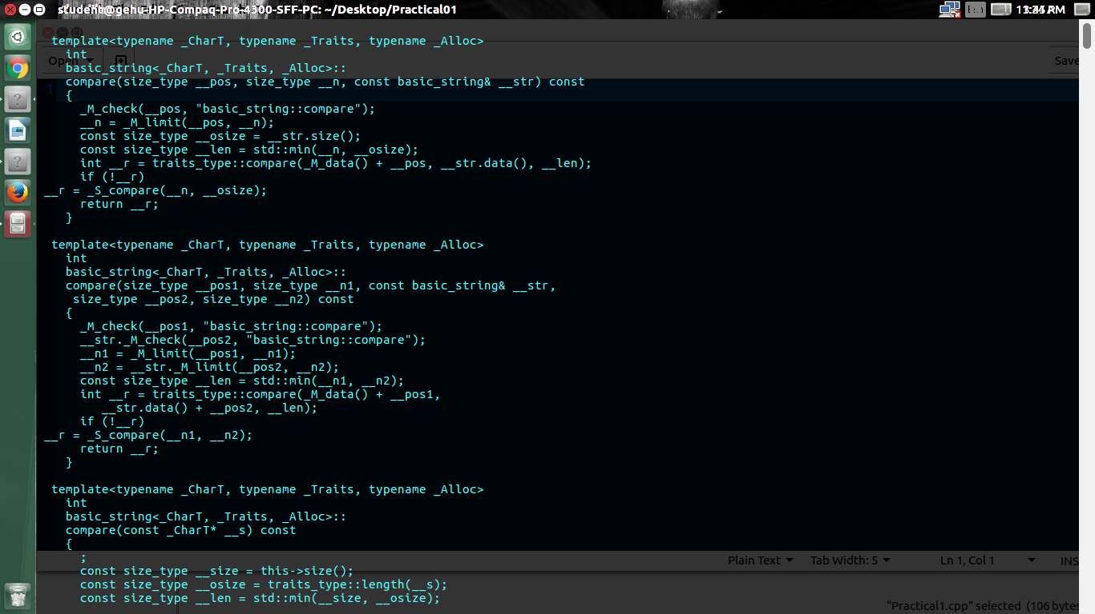

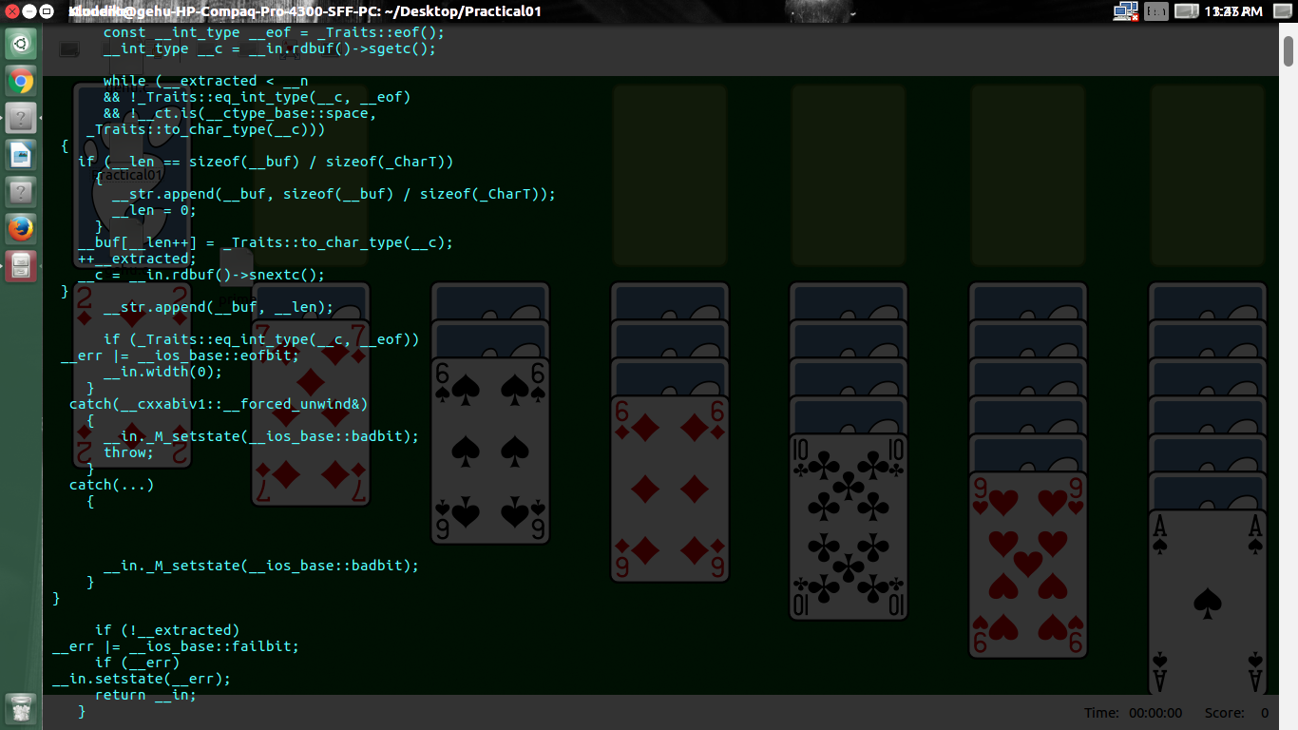

**Program 2**

**Source Code:**

**#include <iostream>**

**using namespace std;**

**int main()**

**{**

**int n, i;**

**bool isPrime = true;**

**cout << "Enter a positive integer: ";**

**cin >> n;**

**for (i = 2; i <= n / 2; ++i)**

**{**

**if (n % i == 0)**

**{**

**isPrime = false;**

**break;**

**}**

**}**

**if (isPrime)**

**cout << "prime number";**

**else**

**cout << "not a prime number";**

**return 0;**

**}**

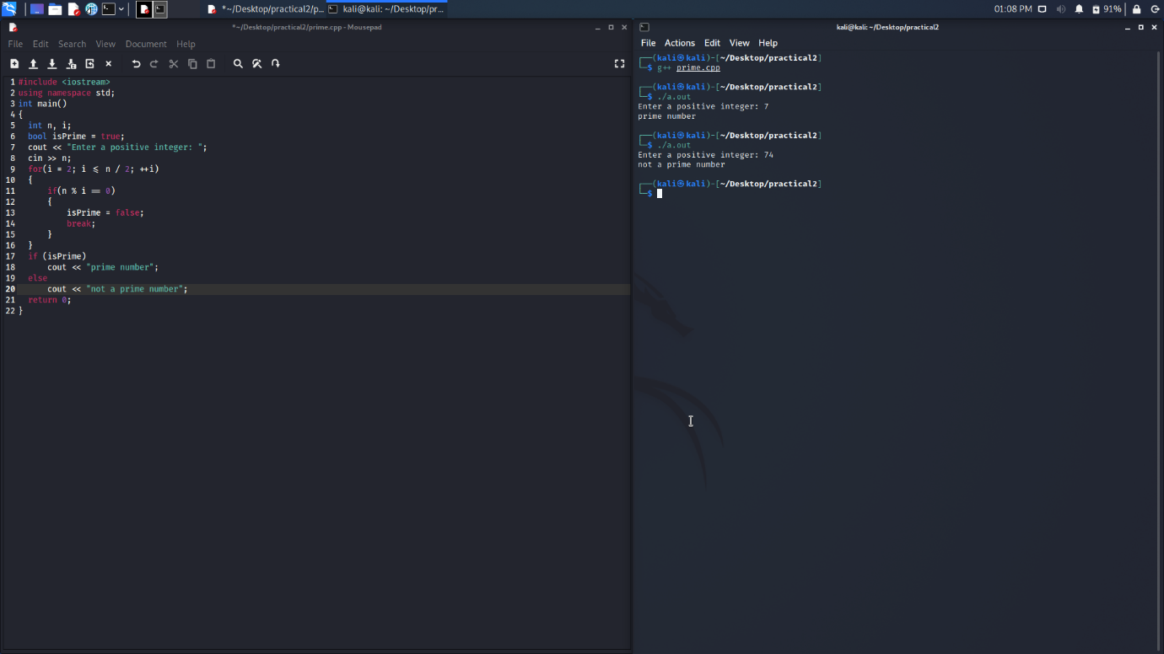

**Program 3**

**Task 1:**

**Source Code:**

#include <iostream.h>

using namespace std;

int main()

{

  cout << "Hello";

}

/*WE are not suppose to use the .h header file

  as the preprocessor will not be able to find

  the respective file and show fatal error

*/

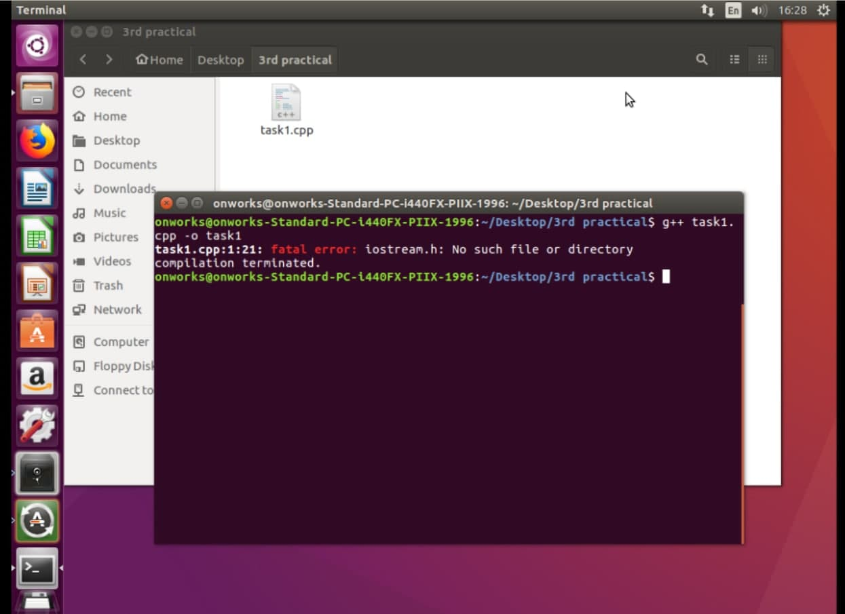

**Program 3**

**Task 2:**

**Source Code:**

using namespace std;

int main()

{

cout << "Hello";

}

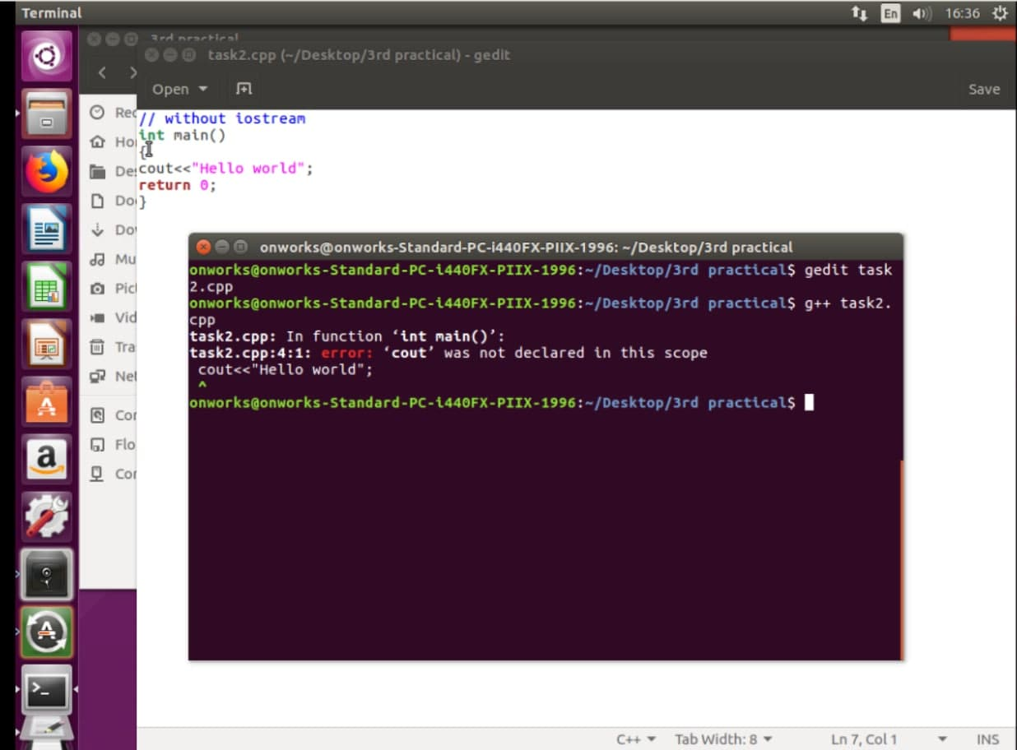

**Program 3**

**Task 3:**

**Source Code:**

#include <iostream>

using namespace std;

int main()

{

char c[10];

cin >> c;

cout << c;

return 0;

}

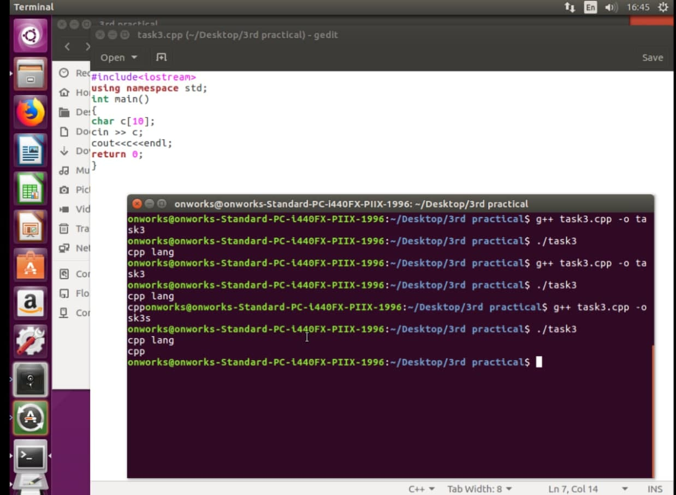

**Program 3**

**Task 4:**

**Source Code:**

#include <iostream>

using namespace std;

int main()

{

string c;

getline(cin, c);

cout << c;

return 0;

}

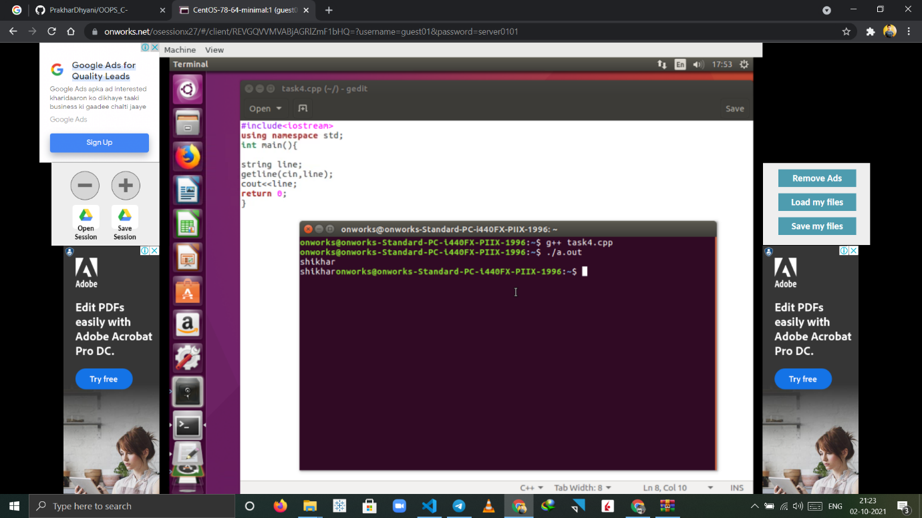

**Program 4**

**Task 1:**

**Source Code:**

#include <iostream>

namespace first

{

int add(int a, int b)

{

return a + b;

}

}

namespace second

{

float add(float a, float b)

{

return a + b;

}

}

int main()

{

std::cout << first::add(1, 5) << "\n";

std::cout << second::add(1, 5.9) << "\n";

std::cout << second::add(1.6, 5) << "\n";

std::cout << first::add(0, 0) << "\n";

return 0;

}

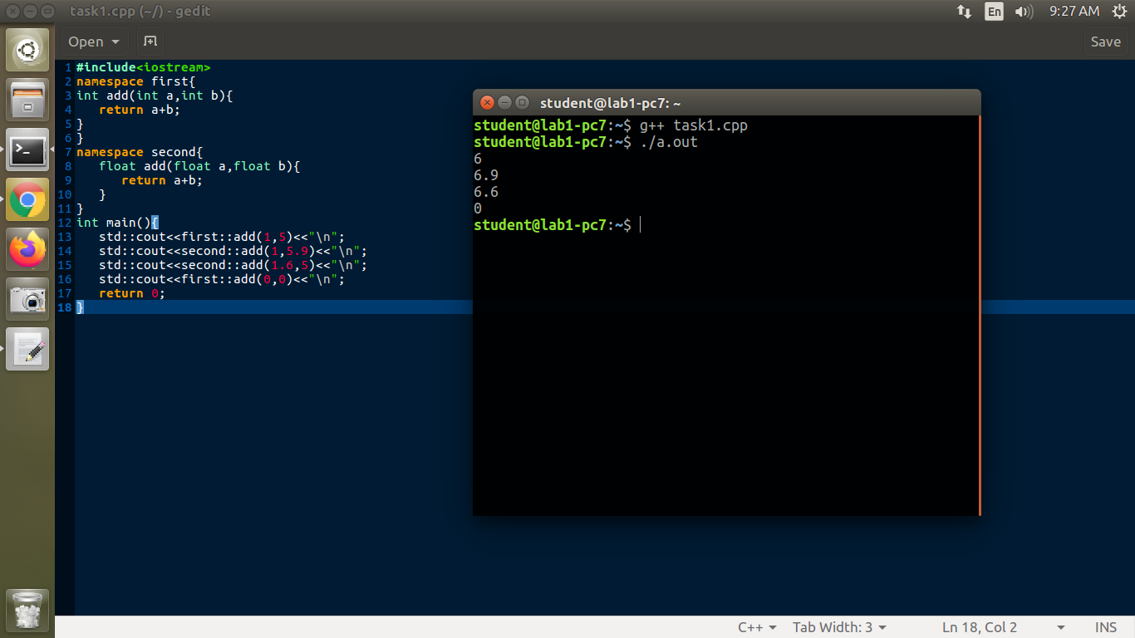

**Program 4**

**Task 2:**

**Source Code:**

#include <iostream>

namespace first

{

int add(int a, int b)

{

return a + b;

}

}

namespace second

{

float add(float a, float b)

{

return a + b;

}

}

using namespace first;

using namespace second;

int main()

{

std::cout << add(1, 5) << "\n";

std::cout << add(1, 5.9) << "\n";

std::cout << add(1.6, 5) << "\n";

std::cout << add(0, 0) << "\n";

return 0;

}

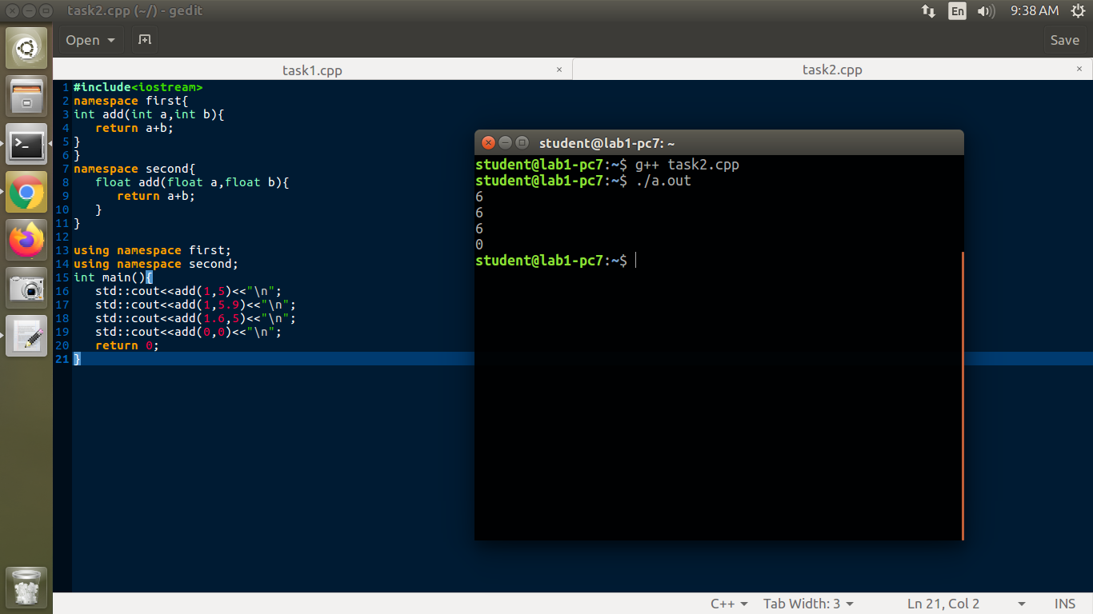

**Program 4**

**Task 3:**

**Source Code:**

#include <iostream>

namespace second

{

float add(float a, float b)

{

return a + b;

}

}

namespace first

{

int add(int a, int b)

{

return a + b;

}

}

int main()

{

std::cout << add(1, 5) << "\n";

std::cout << add(1, 5.9f) << "\n";

std::cout << add(1.6f, 5) << "\n";

//std::cout<<second::add( 1.1f , 6.5f )<<"\n";

std::cout << add(0, 0) << "\n";

return 0;

}

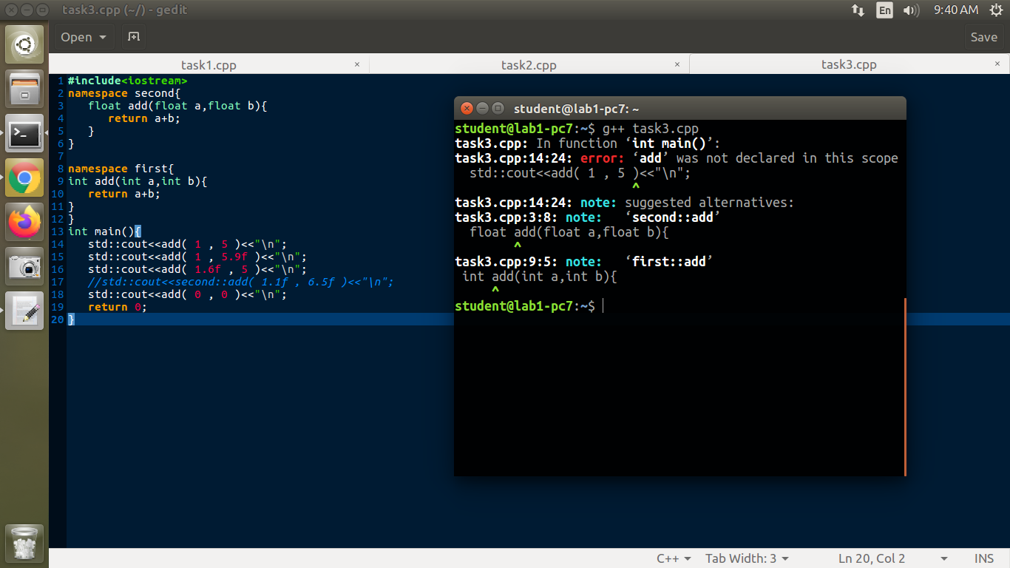

**Program 5**

**Task 1:**

**Source Code:**

**#include <iostream>**

**#include <iomanip>**

**using namespace std;**

**void boolFun()**

**{**

**bool a = 10 > 9;**

**cout << "boolFun() : " << a << endl;**

**}**

**void shortFun()**

**{**

**short a = 10;**

**cout << "shortFun() : " << a << endl;**

**}**

**void intFun()**

**{**

**int a = 10;**

**cout << "intFun() : " << a << endl;**

**}**

**void floatFun()**

**{**

**float a = 10.67235478632f;**

**cout << "floatFun() : " << setprecision(7) << a << endl;**

**}**

**void doubleFun()**

**{**

**double a = 10.76873648723476219384793821;**

**cout << "doubleFun() : " << setprecision(15) << a << endl;**

**}**

**void wideCharFun()**

**{**

**wchar_t a = L'p';**

**cout << "wideCharFun() : " << a << endl;**

**}**

**void longDoubleFun()**

**{**

**long double a = 1673821837.6128736;**

**cout << "wideCharFun() : " << setprecision(20) << a << endl;**

**}**

**void longFun()**

**{**

**long a = 167382183767;**

**cout << "longFun() : " << a << endl;**

**}**

**int main()**

**{**

**boolFun();**

**shortFun();**

**intFun();**

**longFun();**

**floatFun();**

**doubleFun();**

**longDoubleFun();**

**wideCharFun();**

**}**

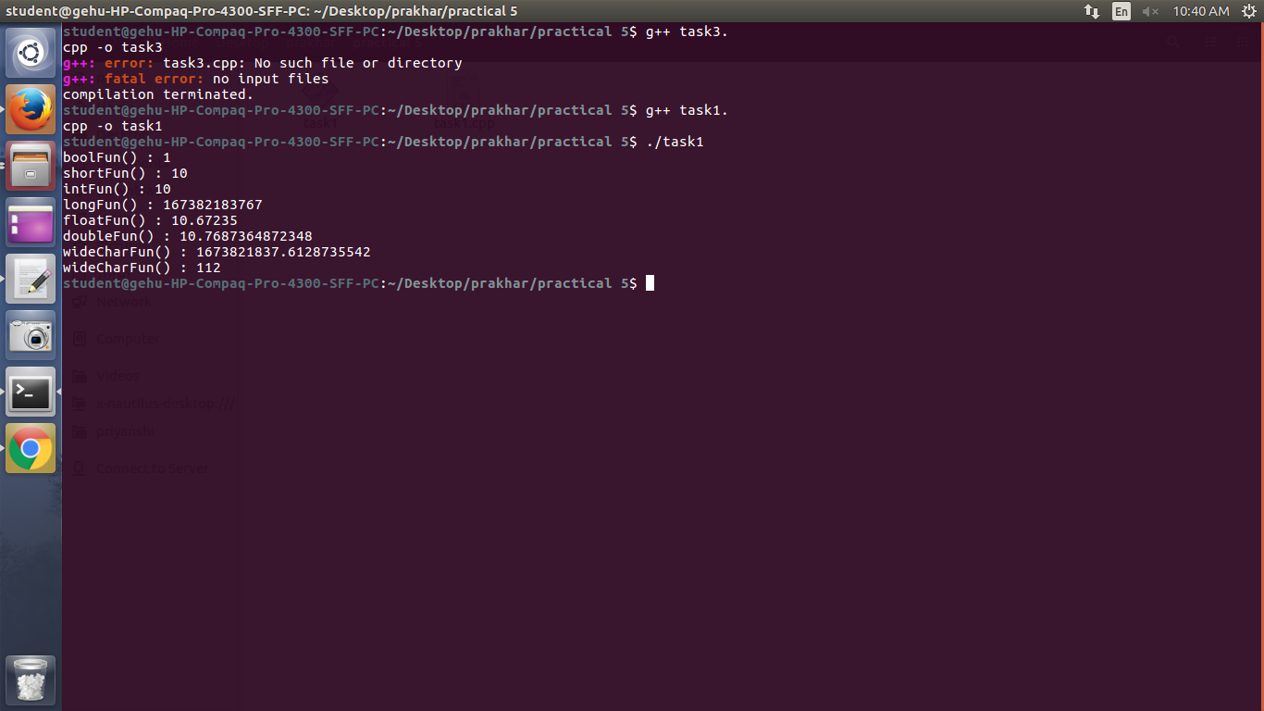

**Program 5**

**Task 2:**

**Source Code:**

#include <iostream>

#include <iomanip>

using namespace std;

void charfxn()

{

char ch = 'a';

cout << "charfxn() : " << ch << " " << sizeof(ch) << "\n";

}

void boolfxn()

{

bool a = 10 > 9;

cout << "boolfxn() : " << a << " " << sizeof(a) << endl;

}

void shortfxn()

{

short a = 2;

cout << "shortfxn() : " << a << " " << sizeof(a) << endl;

}

void intfxn()

{

int a = 89;

cout << "intfxn() : " << a << " " << sizeof(a) << endl;

}

void longfxn()

{

long s = 67;

cout << "longfxn() : " << s << " " << sizeof(s) << endl;

}

void floatfxn()

{

float val = 7.9123467f;

cout << "floatfxn() : " << std::fixed << setprecision(8) << val << " " << sizeof(val) << endl;

}

void doublefxn()

{

double val = 1.123456789987654;

cout << "doublefxn() : " << std::fixed << setprecision(16) << val << " " << sizeof(val) << endl;

}

void longdoublefxn()

{

long double val = 456.8732591347592;

cout << "longdoublefxn() : " << std::fixed << setprecision(17) << val << " " << sizeof(val) << endl;

}

void widecharfxn()

{

wchar_t a = L's';

cout << "Widecharfxn() : " << a << " " << sizeof(a) << endl;

}

int main()

{

charfxn();

boolfxn();

shortfxn();

intfxn();

longfxn();

floatfxn();

doublefxn();

longdoublefxn();

widecharfxn();

return 0;

}

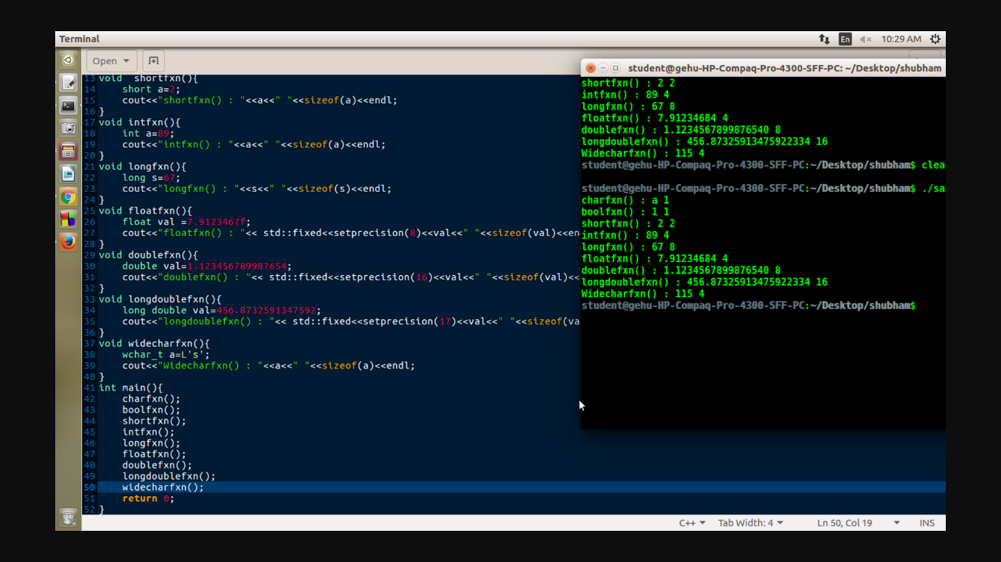

**Program 6**

**Task 1:**

**Source Code:**

#include <iostream>

using namespace std;

int main()

{

  int i1 = 5, i2 = 10;

  float f1 = 4.7, f2 = 8.56;

  string s1 = "Prakhar ", s2 = "Dhyani";

  cout << "int + int " << i1 + i2 << endl;

  cout << "float + float " << f1 + f2 << endl;

  cout << "string + string " << s1 + s2 << endl;

  cout << "int + float " << i1 + f1 << endl;

  cout << "string + int" << s1 + i1 << endl;

  return 0;

}

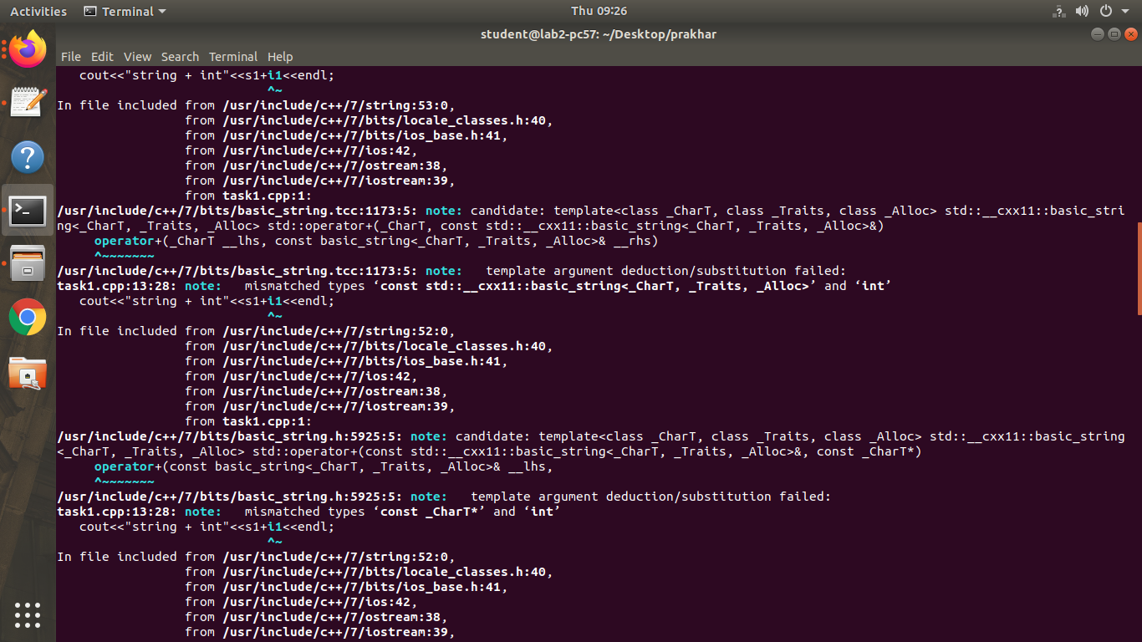

**Program 6**

**Task 2:**

**Source Code:**

#include <iostream>

using namespace std;

int main()

{

    string s;

    cout << "Enter the String" << endl;

    cin >> s;

    int i = 0, j = s.size() - 1;

    while (i < j)

    {

        if (s[i] != s[j])

        {

            cout << "String is not a Palindrome" << endl;

            return 0;

        }

        i++;

        j--;

    }

    cout << "String is a Palindrome " << endl;

    return 0;

}

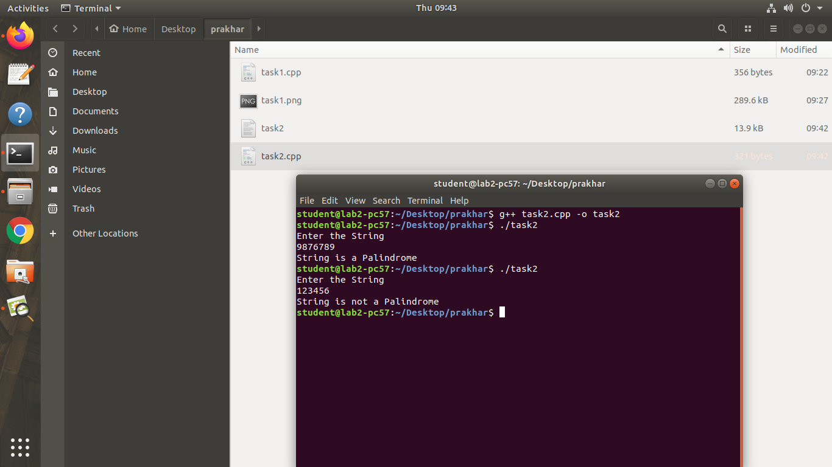

**Program 6**

**Task 3:**

**Source Code:**

#include <iostream>

#include <bits/stdc++.h>

using namespace std;

int main()

{

  string s;

  cout << "Enter the String" << endl;

  cin >> s;

  reverse(s.begin(), s.end());

  cout << " Reverse STring is : " << s << endl;

  return 0;

}

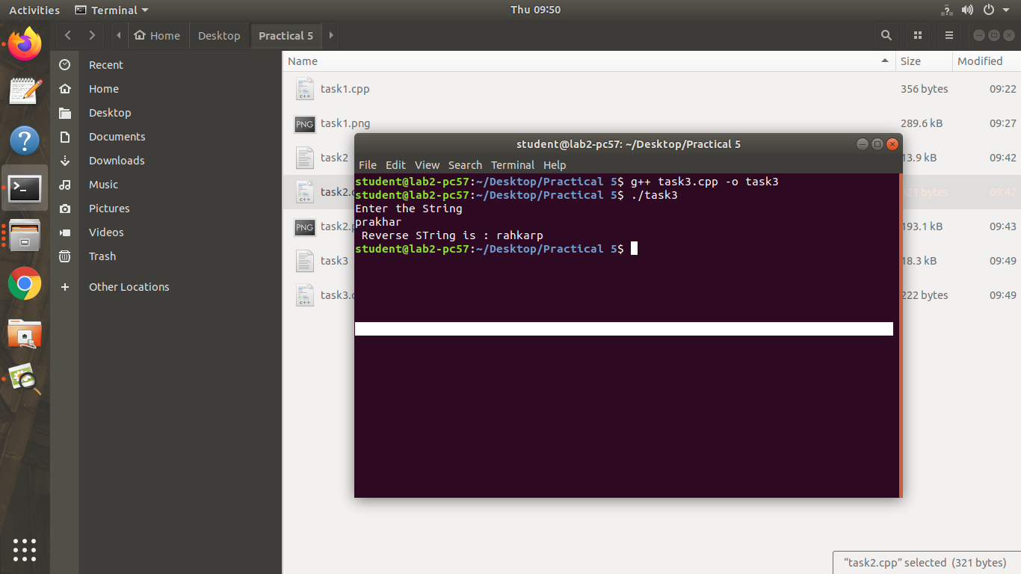

**Program 6**

**Task 4:**

**Source Code:**

#include <iostream>

#include <bits/stdc++.h>

using namespace std;

int main()

{

  string s1, s2;

  cout << "Enter the First String" << endl;

  cin >> s1;

  cout << "Enter the Second String " << endl;

  cin >> s2;

  int n = s1.size(), m = s2.size();

  if (s1.size() != s2.size())

  {

    cout << " Strings are unequal " << endl;

    return 0;

  }

  int max = n > m ? n : m;

  for (int i = 0; i < max; i++)

  {

    if (s1[i] != s2[i])

    {

      cout << " Strings are Unequal " << endl;

      return 0;

    }

  }

  cout << "Strings are Equal" << endl;

  return 0;

}

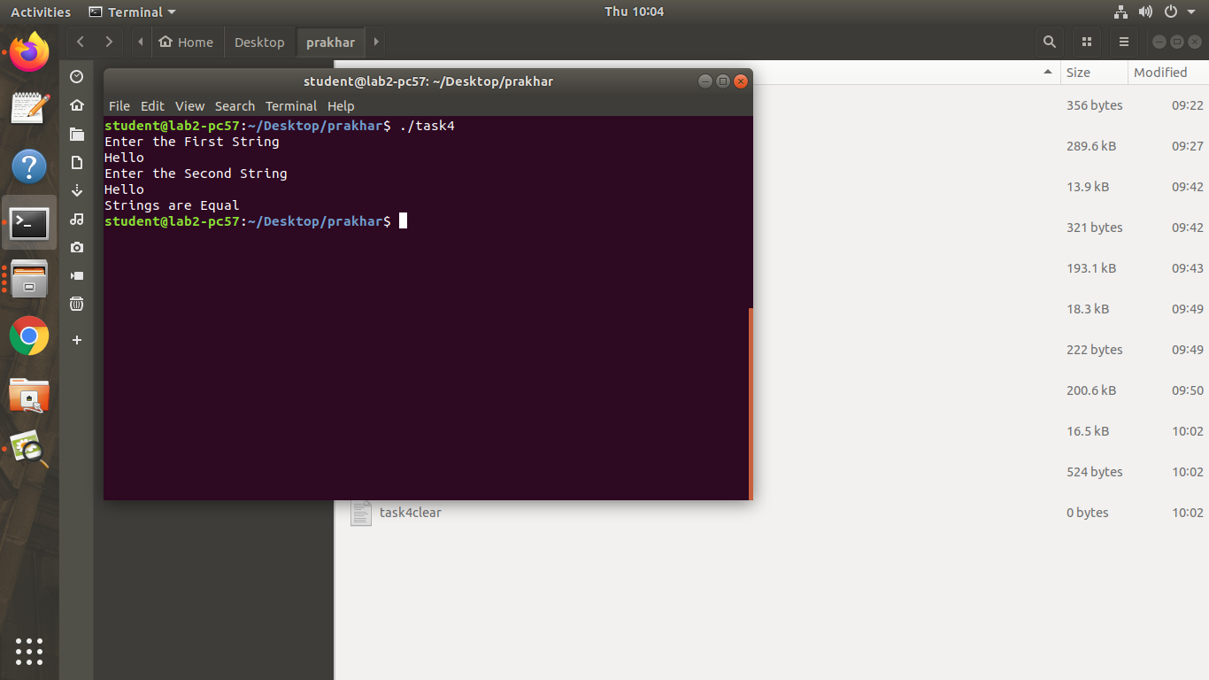

**Program 6**

**Task 5:**

**Source Code:**

#include <iostream>

#include <bits/stdc++.h>

using namespace std;

int main()

{

  string s1, s2;

  cout << "Enter the First String" << endl;

  cin >> s1;

  cout << "Enter the Second String " << endl;

  cin >> s2;

  int ans = s1.compare(s2);

  if (ans == 0)

    cout << "Both strings are equal" << endl;

  else

    cout << " Strings are Unequal " << endl;

  return 0;

}

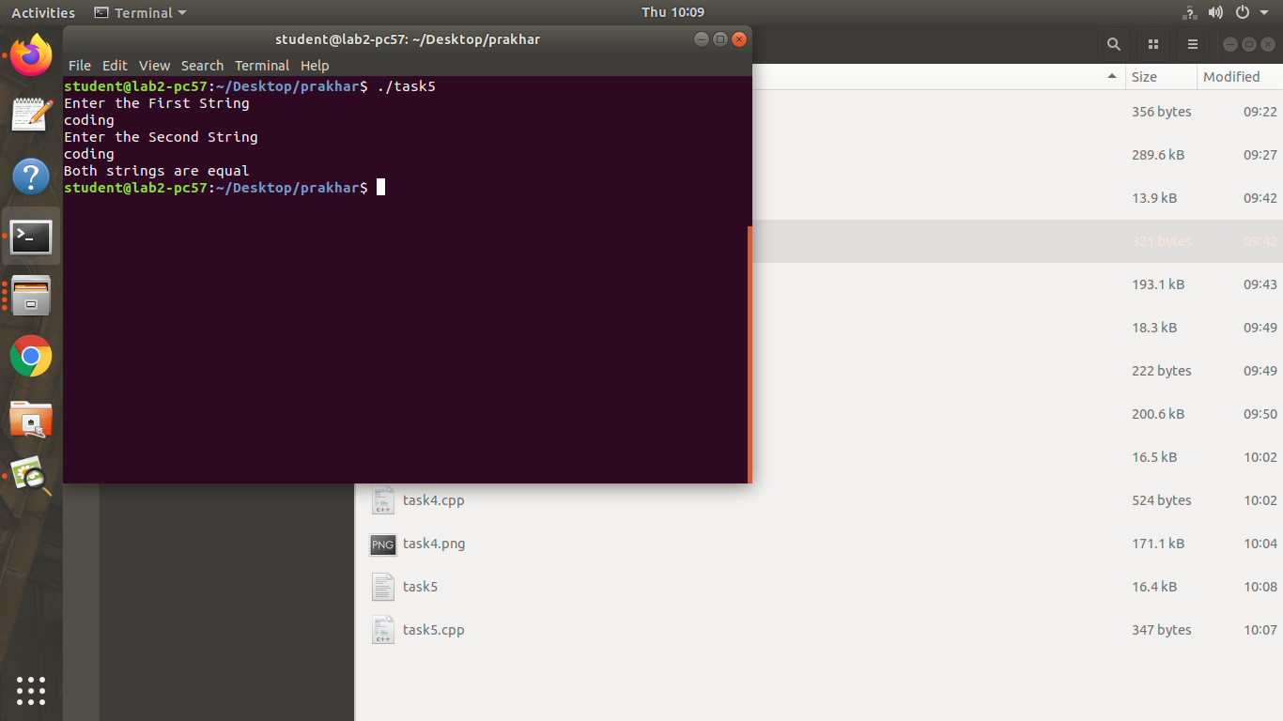

**Program 6**

**Task 6:**

**Source Code:**

#include <iostream>

#include <bits/stdc++.h>

using namespace std;

int main()

{

  string s1;

  cout << "Enter the String" << endl;

  cin >> s1;

  s1[0] = 'j';

  cout << "string is : " << s1 << endl;

  return 0;

}

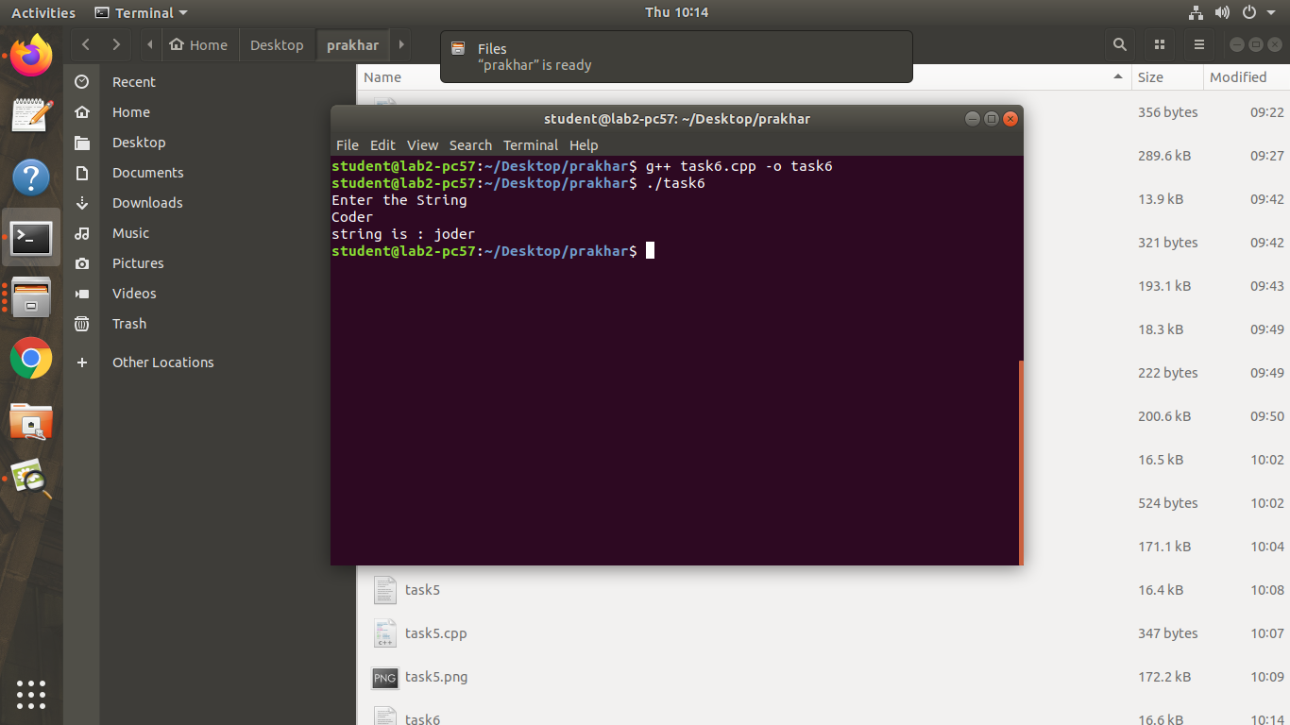

**Program 7**

**Task 1:**

**Source Code:**

#include<iostream>

#include<stdlib.h>

using namespace std;

int main()

{

int choice;

cout<<"1. Current Year \t\t2.Current Month \t\t3. Current Date \t\t4.Exit\n";

while(1)

{

cout<<"Enter your choice : ";

cin>>choice;

switch(choice)

{

case 1: cout<<"\n"<<"Current Year : 2021\n";

break;

case 2: cout<<"\n"<<"Current Month : October\n";

break;

case 3: cout<<"\n"<<"Current Date : 13-10-2021\n";

break;

case 4: exit(0);

break;

default:cout<<"Choice Invalid !\n";

}

}

return 0;

}

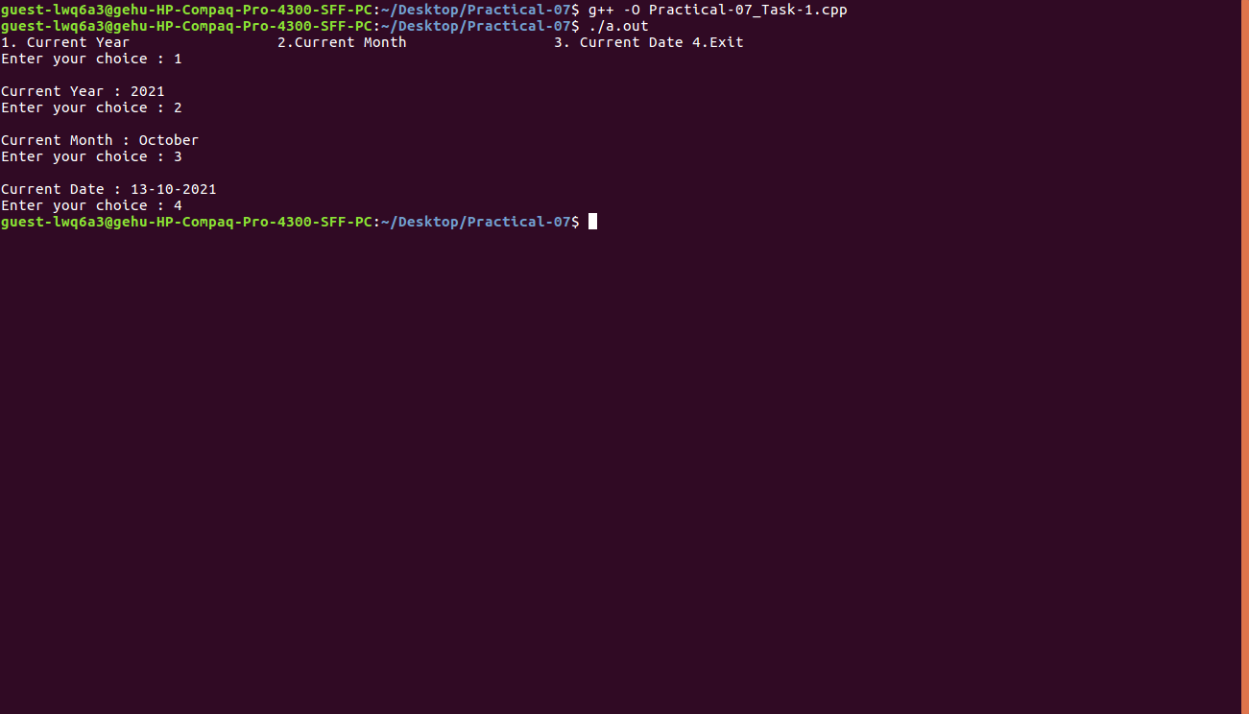

**Program 7**

**Task 2:**

**Source Code:**

#include <iostream>

#include <ctime>

using namespace std;

int main()

{

  int d, m, y;

  char c;

  cout << "enter d for date" << endl

       << "enter m for month" << endl

       << "enter y for year" << endl;

  cin >> c;

  time_t now = time(0);

  tm *ltm = localtime(&now);

  switch (c)

  {

  case 'd':

    cout << "Day: " << ltm->tm_mday << endl;

    break;

  case 'm':

    cout << "Month: " << 1 + ltm->tm_mon << endl;

    break;

  case 'y':

    cout << "Year:" << 1900 + ltm->tm_year << endl;

    break;

  }

}

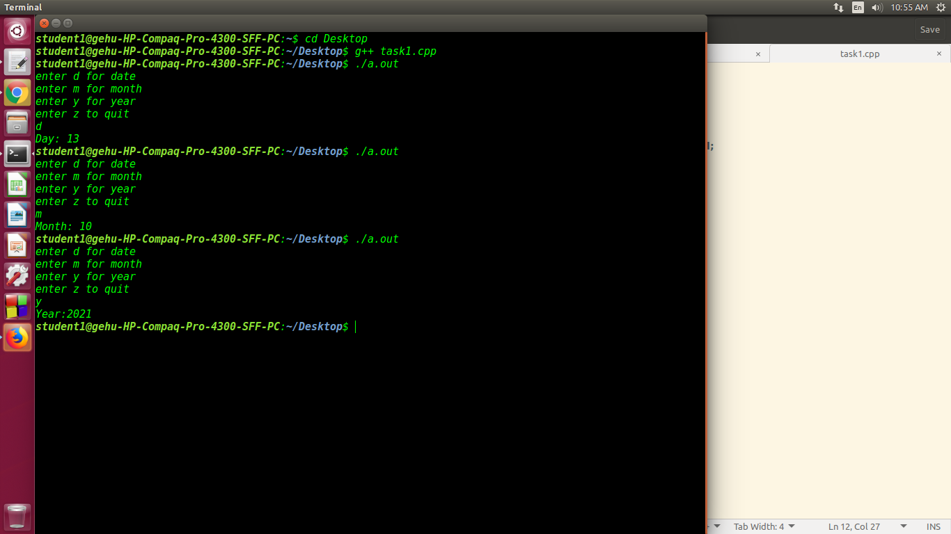

**Program 7**

**Task 3 v1:**

**Source Code:**

#include <iostream>

using namespace std;

int main()

{

int arr[3][3], j, n, i;

cout << "Enter the value of n : ";

cin >> n;

cout << "Enter 2D Matrix"

<< "\n";

for (i = 0; i < n; i++)

{

for (j = 0; j < n; j++)

{

cin >> arr[i][j];

}

}

cout << "\nResultant matrix : \n";

for (i = n - 1; i >= 0; i--)

{

for (j = n - 1; j >= 0; j--)

{

cout << arr[i][j] << " ";

}

cout << "\n";

}

return 0;

}

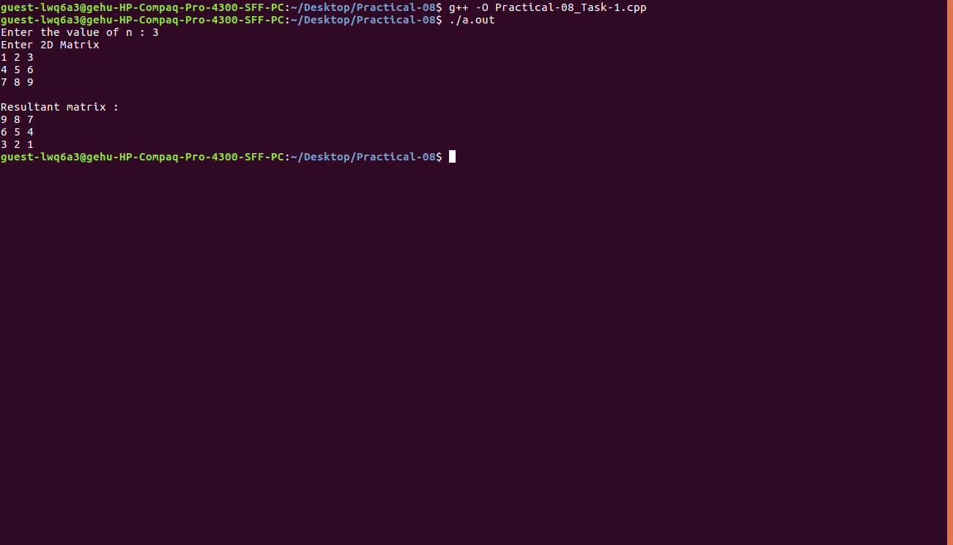

**Program 7**

**Task 3 v2:**

**Source Code:**

#include<iostream>

using namespace std;

int main()

{

int arr[3][3],j,n,i;

cout<<"Enter the value of n : ";

cin>>n;

cout<<"Enter 2D Matrix"<<"\n";

for(i=0;i<n;i++)

{

for(j=0;j<n;j++)

{

cin>>arr[i][j];

}

}

cout<<"\nResultant matrix : \n";

for(i=0;i<n;i++)

{

for(j=0;j<n;j++)

{

cout<<10-arr[i][j]<<" ";

}

cout<<"\n";

}

return 0;

}

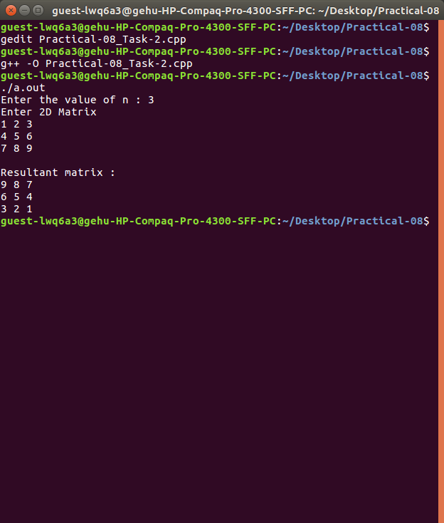

**Program 7**

**Task 3 v3:**

**Source Code:**

#include<iostream>

using namespace std;

int main()

{

int arr[3][3],j,n,i;

cout<<"Enter the value of n : ";

cin>>n;

cout<<"Enter 2D Matrix"<<"\n";

for(i=0;i<n;i++)

{

for(j=0;j<n;j++)

{

cin>>arr[i][j];

arr[i][j]=10-arr[i][j];

}

}

cout<<"\nResultant matrix : \n";

for(i=0;i<n;i++)

{

for(j=0;j<n;j++)

{

cout<<arr[i][j]<<" ";

}

cout<<"\n";

}

return 0;

}

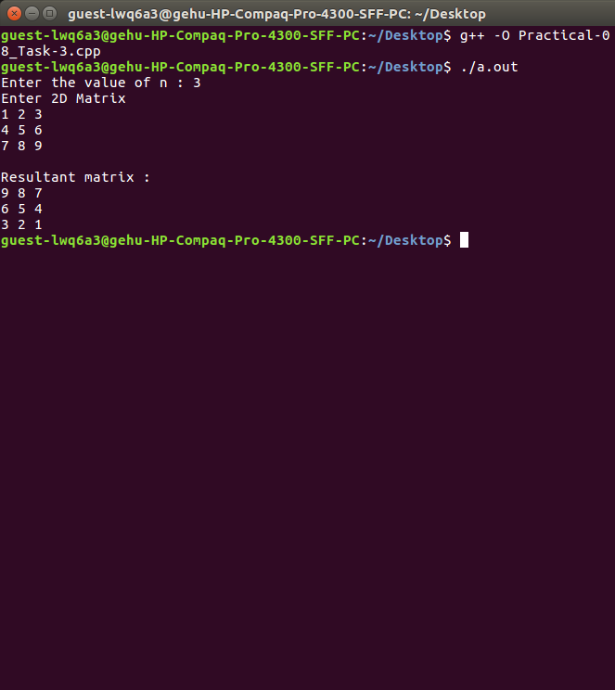

**Program 7**

**Task 3 v4:**

**Source Code:**

#include <iostream>

using namespace std;

int main()

{

int N = 3;

int arr[N][N];

for(int i = 0 ; i < N ; i++){

for(int j = 0 ; j < N ; j++)

cin >> arr[i][j];

}

int i = 0, k = N-1;

while(i <= k){

for(int j = 0 ; j < N ; j++){

swap(arr[i][j],arr[k][j]);

}i++;

k--;

}

int y = 0, z = N-1;

while(y <= z){

for(int x = 0 ; x < N ; x++){

swap(arr[x][y],arr[x][z]);

}y++;

z--;

} cout << "\nFinal array : " << endl;

for(int i = 0 ; i < N ; i++){

for(int j = 0 ; j < N ; j++)

cout << arr[i][j] << " ";

cout << "\n";

}

return 0;

}

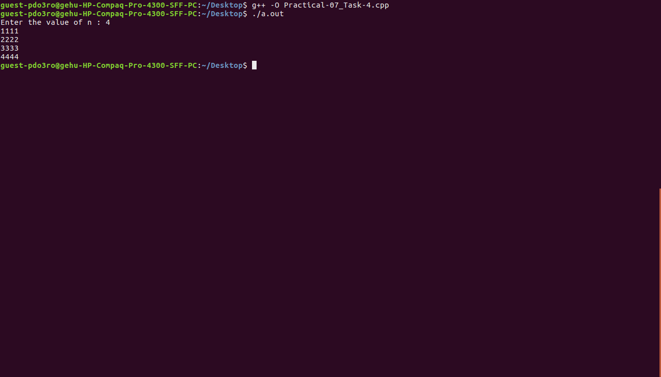

**Program 7**

**Task 4 v1:**

**Source Code:**

#include<iostream>

using namespace std;

int main()

{

int i,j,n,arr[3][3];

cout<<"Enter the value of n : ";

cin>>n;

for(i=0;i<n;i++)

{

for(j=0;j<n;j++)

{

cin>>arr[i][j];

}

}

for(i=0;i<n;i++)

{

for(j=0;j<n;j++)

{

cout<<i+1;

}

cout<<"\n";

}

return 0;

}



**Program 7**

**Task 4 v2:**

**Source Code:**

#include<iostream>

using namespace std;

int main()

{

int arr[3][3];

int i,j,n;

cout<<"Enter the value of n : ";

cin>>n;

for(i=0;i<n;i++)

{

for(j=0;j<n;j++)

{

cin>>arr[i][j];

}

}

cout<<"\nOutput : \n";

for(i=0;i<n;i++)

{

for(j=0;j<n;j++)

{

cout<<arr[i][n-1]/3<<" ";

}

cout<<"\n";

}

}

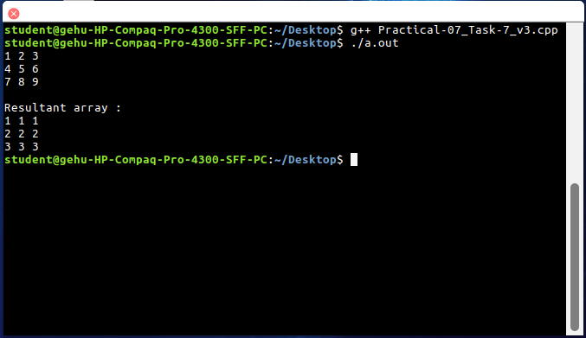

**Program 7**

**Task 4 v3:**

**Source Code:**

#include<iostream>

using namespace std;

int main()

{

int N;

cout<<"Enter the value of N : ";

cin>>N;

int arr[N][N];

for(int i = 0 ; i < N ; i++)

{

for(int j = 0 ; j < N ; j++)

{

cin >> arr[i][j];

}

}

for(int i = 0 ; i <= N ; i++)

{

for(int j = 0 ; j <= N ; j++)

{

arr[i][j] = ((j*10+i)%10)+1;

}

}

cout << "\nResultant array : " << endl;

for(int i = 0 ; i < N ; i++)

{

for(int j = 0 ; j < N ; j++)

{

cout << arr[i][j] << " ";

}

cout << "\n";

}

return 0;

}



**Program 7**

**Task 5:**

**Source Code:**

#include<iostream>

using namespace std;

int main()

{

int i,j,n;

cout<<"Enter the value of n : ";

cin>>n;

for(i=0;i<n;i++)

{

for(j=0;j<=i;j++)

{

cout<<"*"<<" ";

}

cout<<"\n";

}

return 0;

}

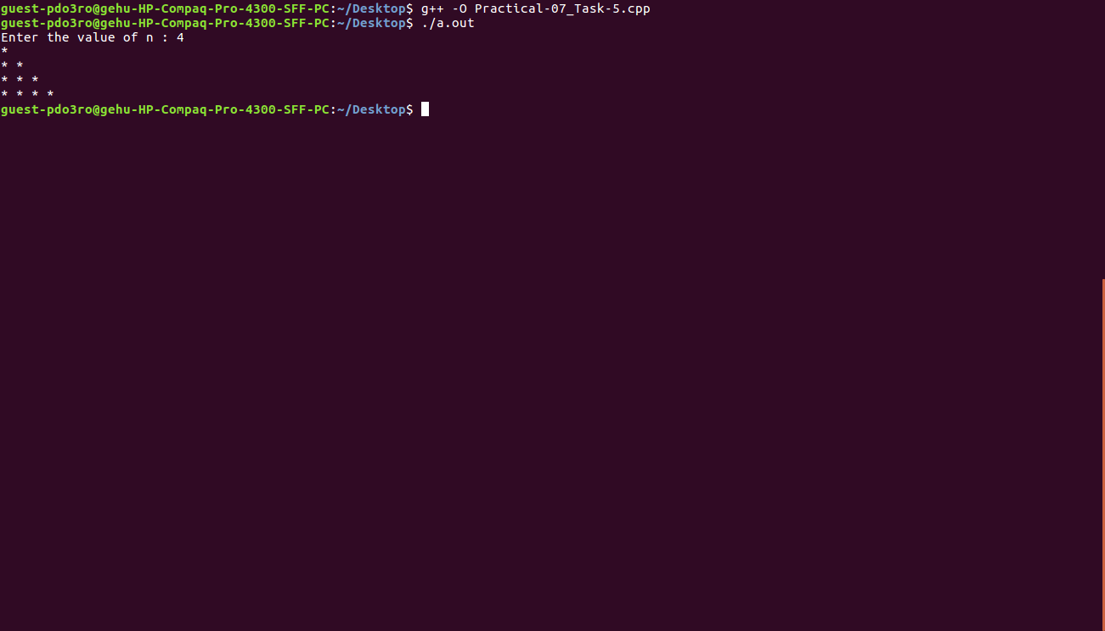

**Program 7**

**Task 6:**

**Source Code:**

#include<iostream>

using namespace std;

int main()

{

int i,j,n;

char arr[n][n];

cout<<"Enter the value of n : ";

cin>>n;

for(j=n-1;j>=0;j--)

{

for(i=0;i<=j;i++)

{

cout<<"* ";

}

cout<<"\n";

}

return 0;

}

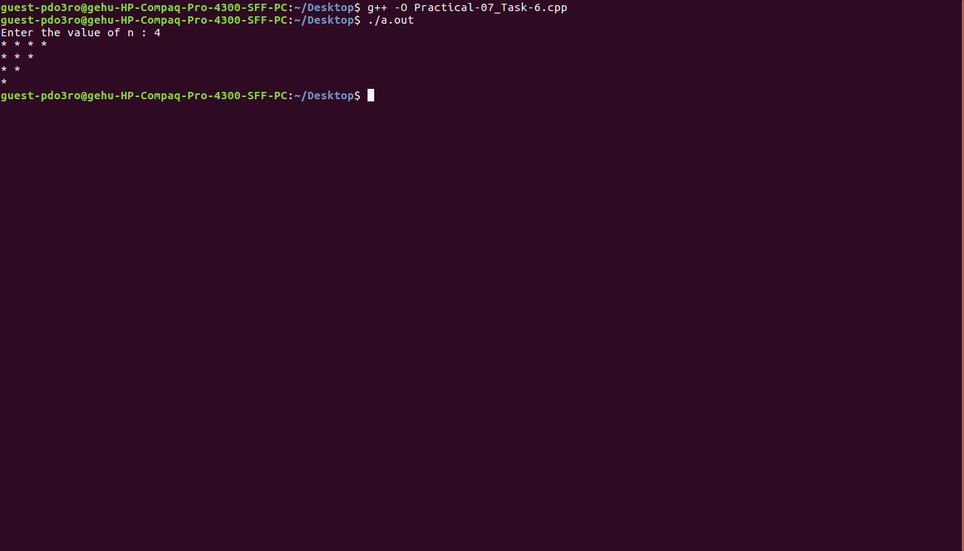

**Program 7**

**Task 7:**

**Source Code:**

#include<iostream>

using namespace std;

int main()

{

int i,j,n;

cout<<"Enter the value of n :";

cin >> n;

for(i=0;i<n;i++)

{

for(j=0;j<n;j++)

{

int sum = i + j;

if(sum>=n-1)

cout<<"*";

else

cout<<" ";

}cout<<"\n";

}

return 0;

}

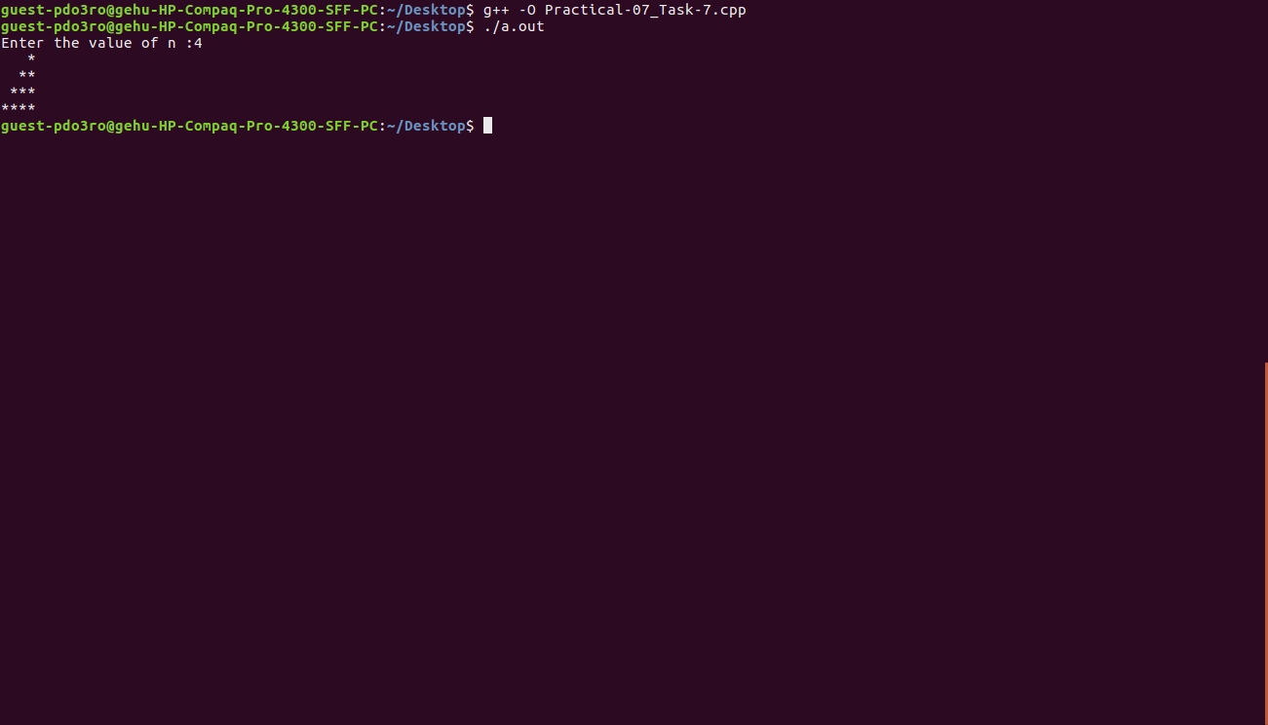

**Program 7**

**Task 8:**

**Source Code:**

#include<iostream>

using namespace std;

int main()

{

int i,j,n;

cout<<"Enter the value of n :";

cin >> n;

for(i=0;i<n;i++)

{

for(j=0;j<n;j++)

{

int sum = i + j;

if(sum<=n-1)

cout<<"*";

else

cout<<" ";

}cout<<"\n";

}

return 0;

}

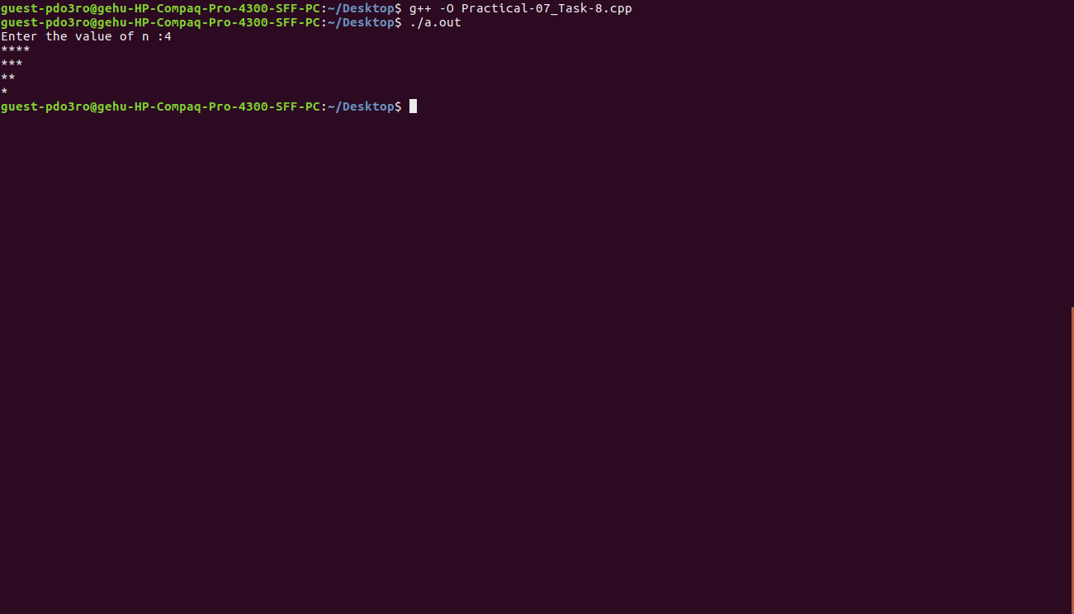

**Program 8**

**Task 1:**

**Source Code:**

#include<iostream>

using namespace std;

int main(){

int *p={10,20,30};

cout<<*p<<" " ;

p++;

cout<<*p;

return 0;

}

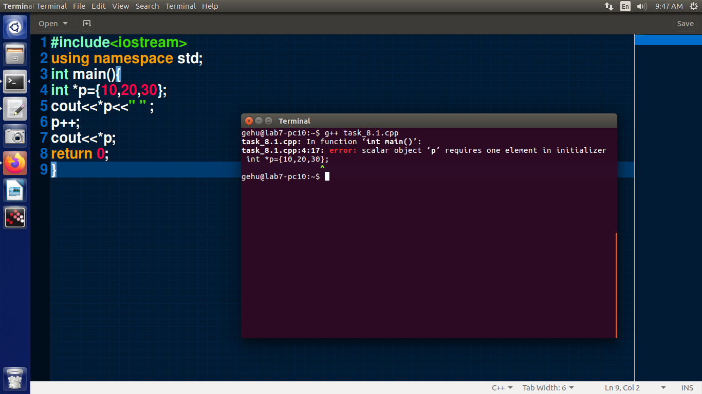

**Program 8**

**Task 2:**

**Source Code:**

**Program 8**

**Task 3:**

**Source Code:**

#include <iostream>

using namespace std;

int main()

{

int a = 10;

int *p = &a;

int **q = &p;

cout << a << " ";

*p = 20;

cout << *p << " ";

**q = 30;

cout << **q << endl;

return 0;

}

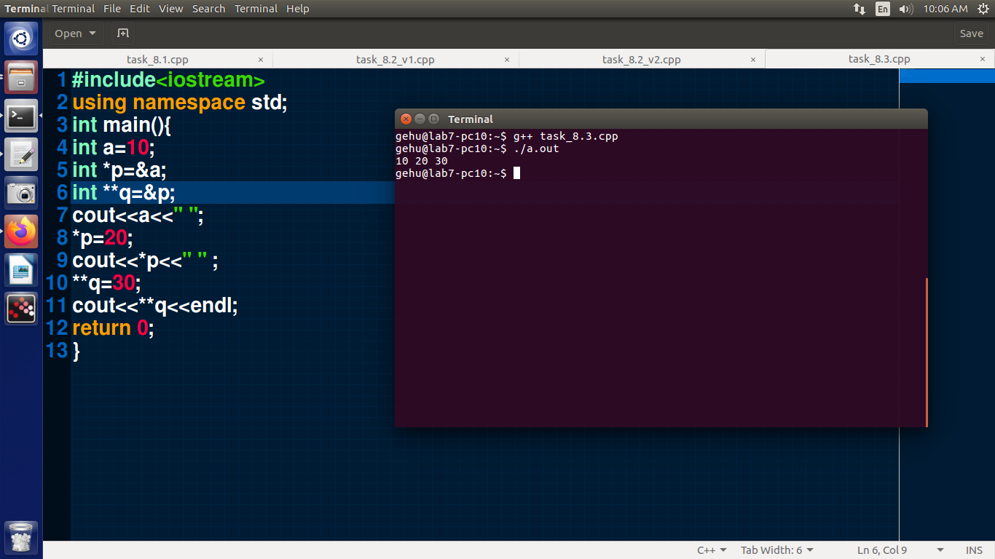

**Program 8**

**Task 4:**

**Source Code:**

#include <iostream>

using namespace std;

void factorial(int n)

{

int fact = 1;

while (n)

{

fact = fact * n;

n--;

}

cout << fact << " ";

return;

}

int main()

{

int n;

cin >> n;

factorial(n);

return 0;

}

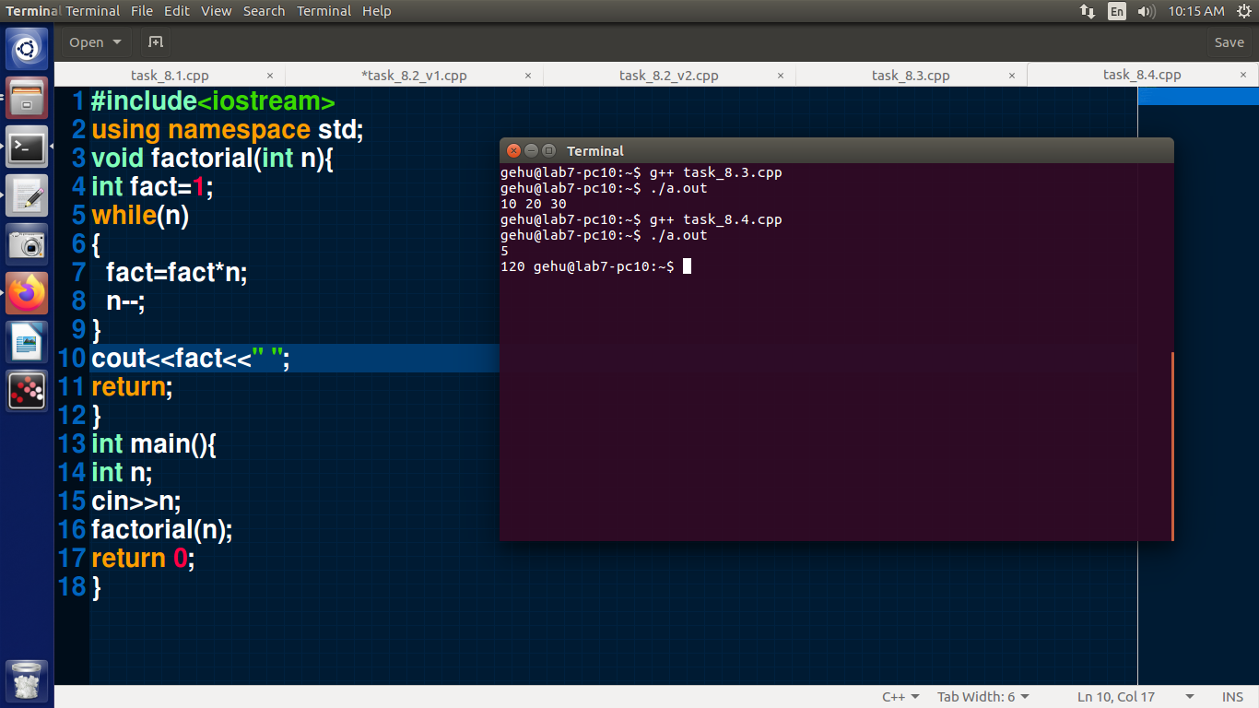

**Program 8**

**Task 5:**

**Source Code:**

#include <iostream>

using namespace std;

int factorial(int n)

{

if (n == 0 || n == 1)

return 1;

return n * factorial(n - 1);

}

int main()

{

int n;

cin >> n;

int fact = factorial(n);

cout << fact << " ";

return 0;

}

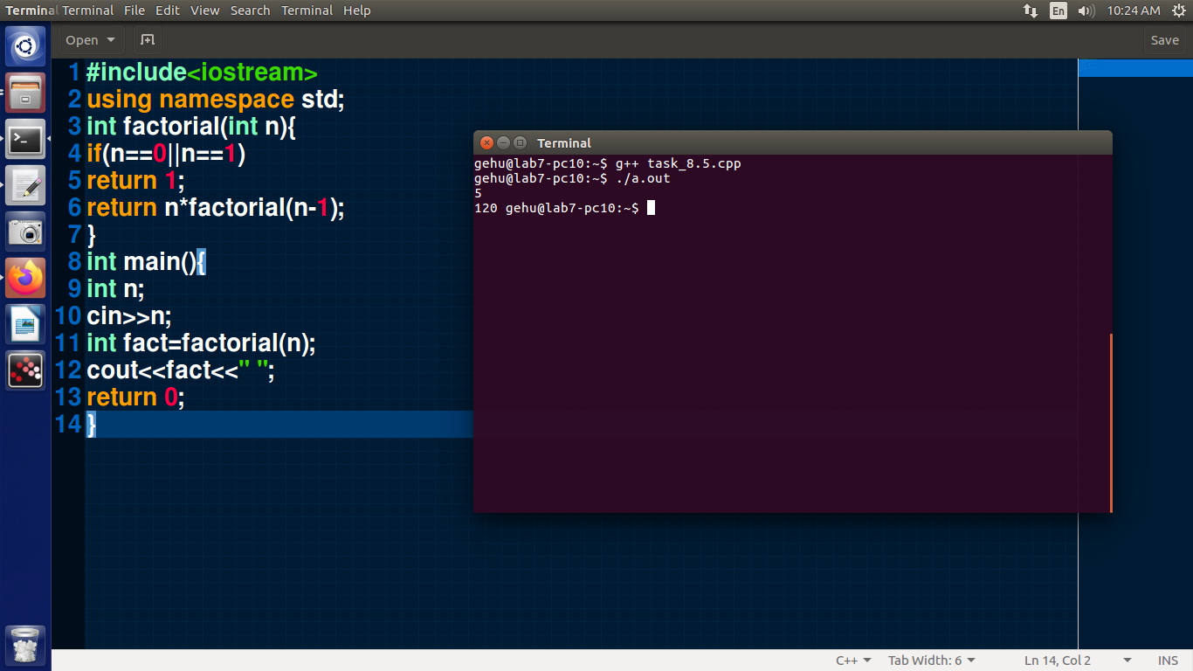

**Program 8**

**Task 6:**

**Source Code:**

#include <bits/stdc++.h>

using namespace std;

void seq(int n)

{

if (n == 1)

{

return;

}

seq(n - 1);

cout << n * (pow(n - 1, n - 1) + n - 1) << " ";

return;

}

int main()

{

int n;

cin >> n;

seq(n);

return 0;

}

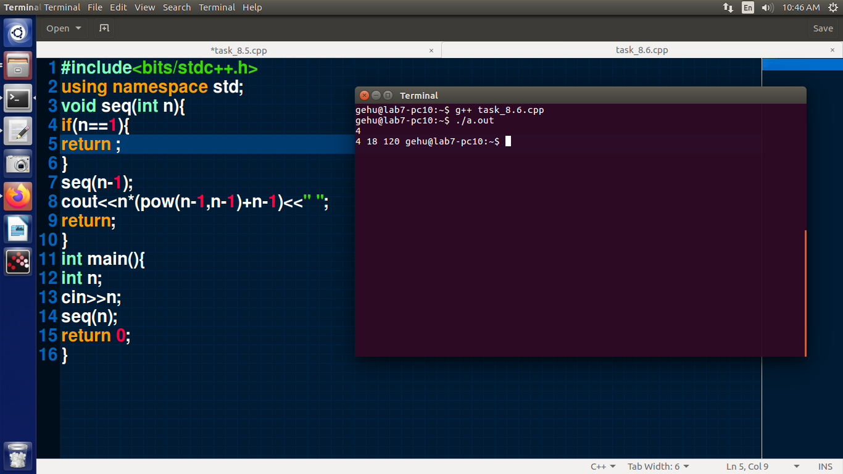

**Program 8**

**Task 7 v1:**

**Source Code:**

#include <iostream>

using namespace std;

void swap(int a, int b)

{

int temp = a;

a = b;

b = temp;

cout << "swap value in swap function " << a << " " << b << endl;

}

int main()

{

int a = 10;

int b = 20;

cout << "value before swap " << a << " " << b << endl;

swap(a, b);

cout << "value after swap in main function " << a << " " << b << endl;

return 0;

}

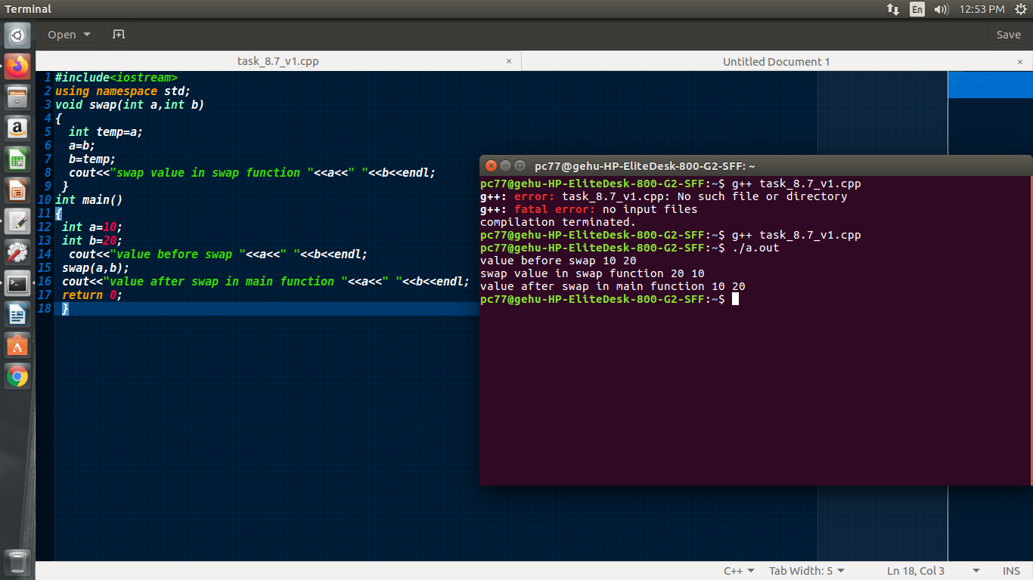

**Program 8**

**Task 7 v2:**

**Source Code:**

#include <iostream>

using namespace std;

void swap(int &a, int &b)

{

int temp = a;

a = b;

b = temp;

cout << "swap value in swap function " << a << " " << b << endl;

}

int main()

{

int a = 10;

int b = 20;

cout << "value before swap " << a << " " << b << endl;

swap(a, b);

cout << "value after swap in main function " << a << " " << b << endl;

return 0;

}

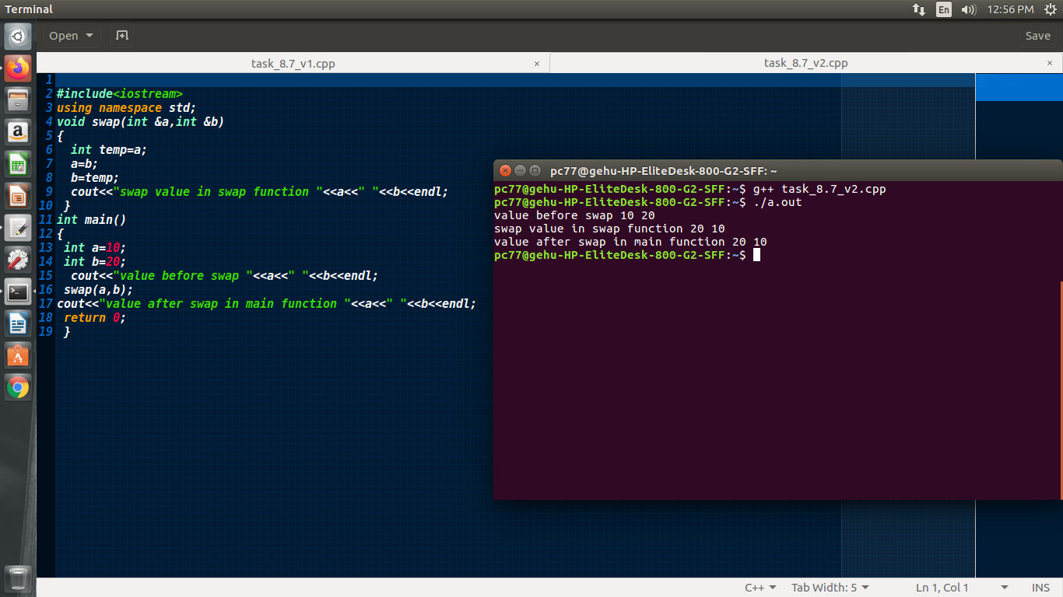

**Program 8**

**Task 7 v3:**

**Source Code:**

**#include <iostream>**

**using namespace std;**

**void swap(int *x, int *y)**

**{**

**int temp = *x;**

**\*x = *y;**

**\*y = temp;**

**cout << "swap value in swap function " << *x << " " << *y << endl;**

**}**

**int main()**

**{**

**int a = 10;**

**int b = 20;**

**cout << "value before swap " << a << " " << b << endl;**

**swap(&a, &b);**

**cout << "value after swap in main function " << a << " " << b << endl;**

**return 0;**

**}**

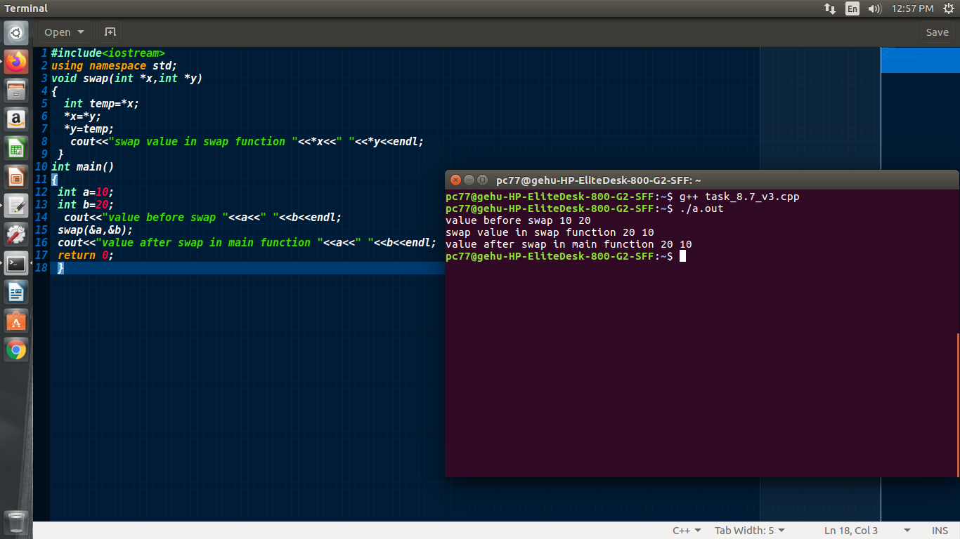

**Program 9**

**Task 1 a:**

**Source Code:**

#include<iostream>

using namespace std;

class student{

public:

int roll_no;

long int phone_no;

string address;

};

int main(){

student Sam,John;

Sam.roll_no=56;

Sam.phone_no=847398573;

Sam.address="kedarpur lane no.4";

John.roll_no=45;

John.phone_no=9862396429;

John.address="mothrowala road dehradun";

cout<<"The details of Sam are :"<<" Roll no: "<<Sam.roll_no<<" Phone no. : "<<Sam.phone_no<<" Address : "<<Sam.address;

cout <<endl;

cout<<"The details of John are :"<<" Roll no: "<<John.roll_no<<" Phone no. : "<<John.phone_no<<" Address : "<<John.address;

}

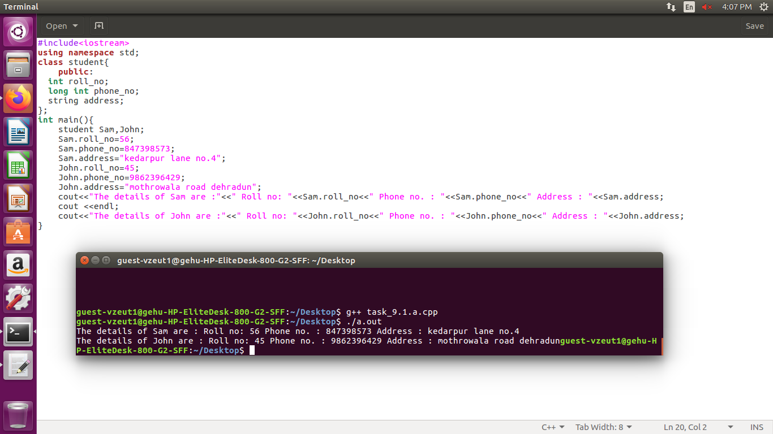

**Program 9**

**Task 1 b:**

**Source Code:**

#include <iostream>

#include <string>

using namespace std;

class student

{ //friend function array

string name;

int marks;

char sec;

public:

void set_values(string name, int m, char sec)

{

this->name = name;

this->marks = m;

this->sec = sec;

}

friend int get_marks(student obj);

};

int get_marks(student obj)

{

return obj.marks;

}

int main()

{

int n;

cout << "enter no. of students" << endl;

cin >> n;

student arr[n];

for (int i = 0; i < n; i++)

{

cout << "enter name,marks and section of student " << i + 1 << endl;

int temp;

string name;

char sec;

cin >> name;

cin >> temp;

cin >> sec;

arr[i].set_values(name, temp, sec);

}

int sum = 0;

for (int i = 0; i < n; i++)

{

sum += get_marks(arr[i]);

}

cout << sum;

}

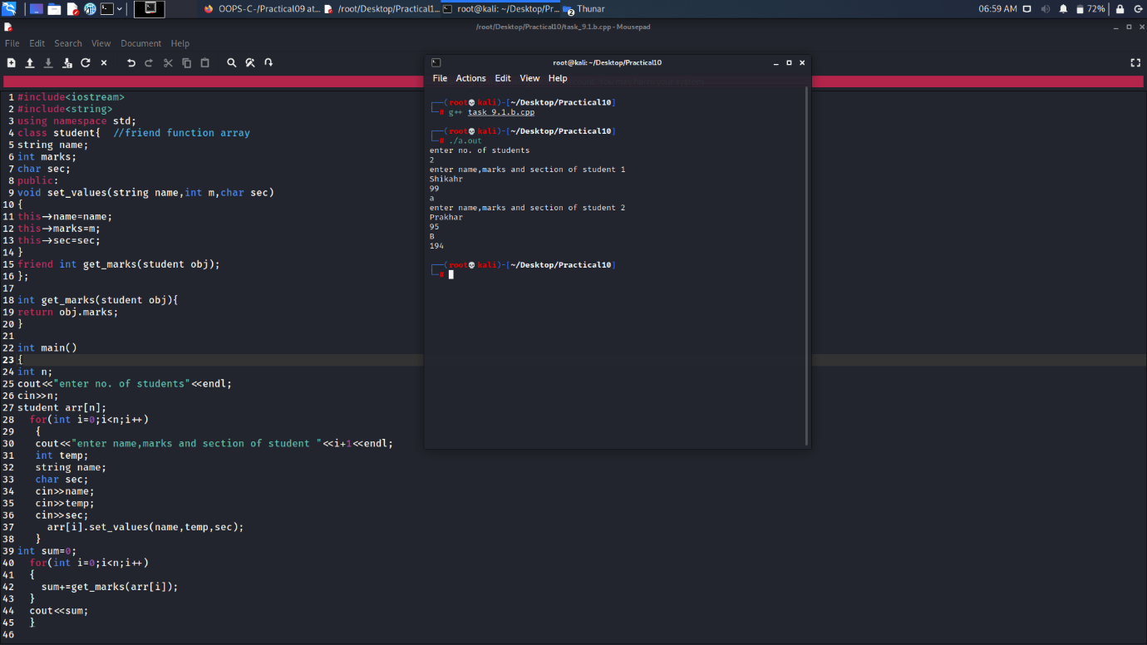

**Program 9**

**Task 2:**

**Source Code:**

#include <iostream>

#include <string>

using namespace std;

class cal_area

{

public:

cal_area(int a)

{

int area = 4 * (a) * (a);

cout << "area of square"

<< " " << area << endl;

}

cal_area(int l, int b)

{

int area = l * b;

cout << "area of rectangle"

<< " " << area << endl;

}

};

int main()

{

cal_area A1(4), A2(3, 4);

}

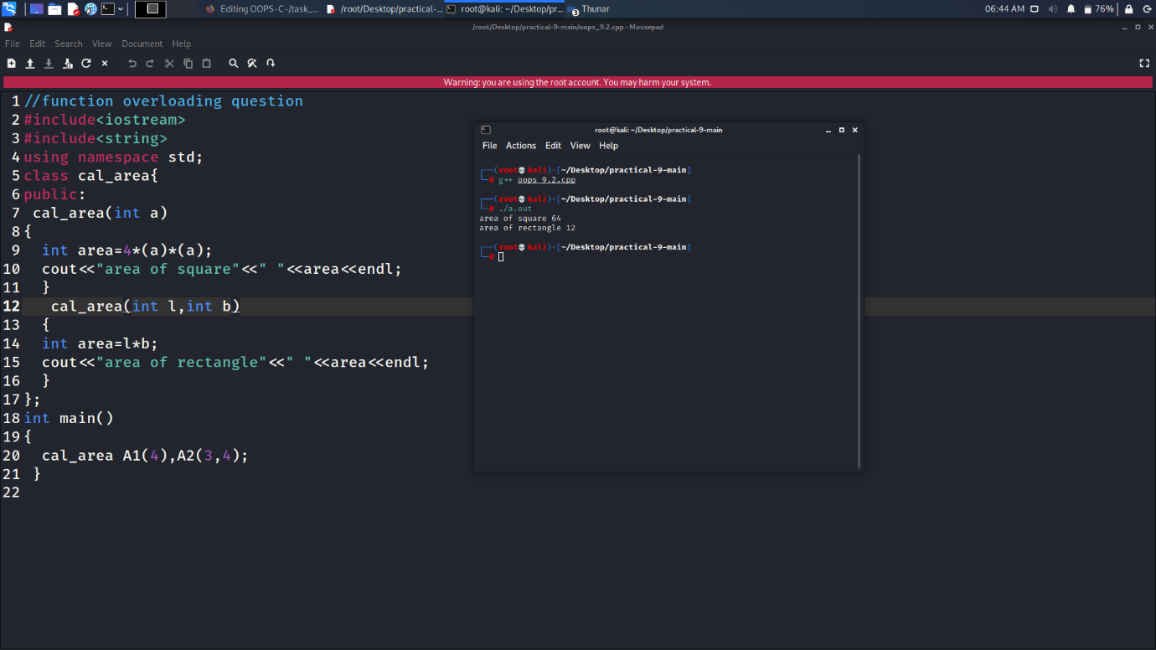

**Program 9**

**Task 3:**

**Source Code:**

#include <iostream>

using namespace std;

class Student

{

string NAME;

int Roll_no;

public:

static int count;

void setValue(string name, int rollno)

{

NAME = name;

Roll_no = rollno;

count++;

}

static int display()

{

return count;

}

};

int Student::count = 0;

int main()

{

Student obj1, obj2, obj3, obj4, obj5;

obj1.setValue("PraKHAR", 50);

obj2.setValue("SHUBHANG", 57);

obj3.setValue("ShiKHAR", 40);

obj4.setValue("ABHISHEk", 3);

cout << "NO< OF TIMES MEMBER FUNCTION CALLED : " << Student::count;

}

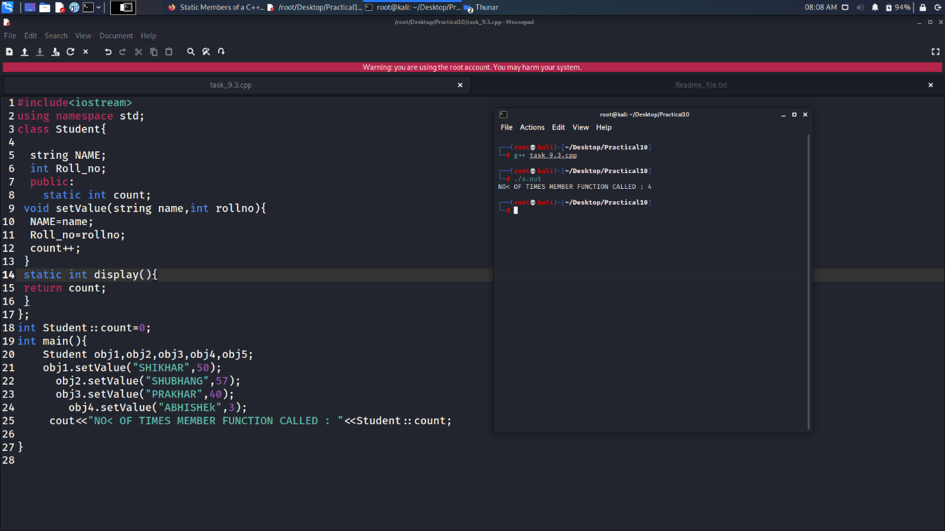

**Program 9**

**Task 4:**

**Source Code:**

//Friend Function in C++

//WAP in which you create a Student class having basic information for each student,

//like name, age and marks. By using friend function add marks of all the students [lets say 3 objects] and print it.

#include <iostream>

#include <string.h>

using namespace std;

class student

{

string name;

int marks;

char sec;

public:

student(string name, int m, char sec)

{

this->name = name;

this->marks = m;

this->sec = sec;

}

friend int get_marks(student);

};

int get_marks(student obj)

{

return obj.marks;

}

int main()

{

student obj1("Shikhar", 99, 'A');

student obj2("shivi", 84, 'B');

student obj3("prakhar", 78, 'B');

int sum = 0;

sum += get_marks(obj1);

sum += get_marks(obj2);

sum += get_marks(obj3);

cout << "total sum of all students marks : " << sum;

}

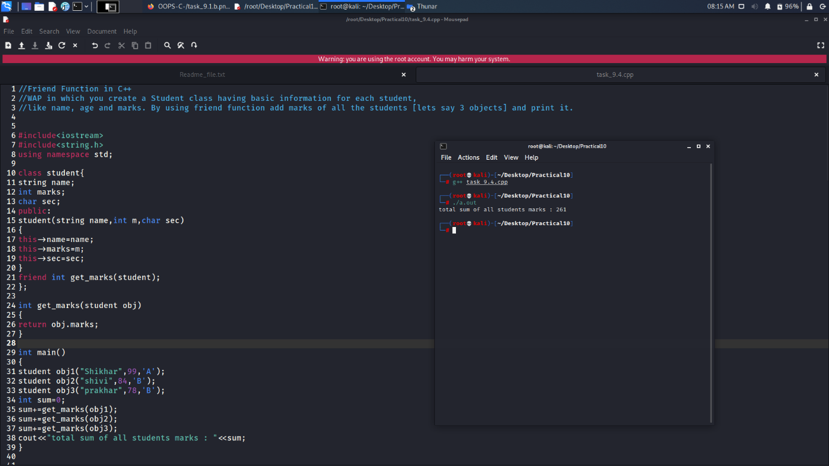

**Program 9**

**Task 5:**

**Source Code:**

//Structure in C++

//WAP to create a College class and Student Structure in C++ in one program. By providing such suitable examples write at least 5 differences between class and struct code your have written above.

//Hint [Access Specifiers, Heap and Stack, large and small memory, etc.]

#include <iostream>

using namespace std;

class college

{

string name;

int roll_no;

};

struct student

{

string name;

int roll_no.

} int main()

{

college t;

student s1;

t.name = "Prakhar"; // compiler error because x is private

t.x = 20; //error concept of data hiding

s1.name = "aedi";

s1.roll_no = 34;

getchar();

return 0;

}

/* ***********************difference between struct and class*********************************

1. access specifier :-a structure is a class defined with struct keyword and access specifier

is by default public where as when class is derived access specifier is by defalut private.

2. security :- data members in class are private the concept of data hiding because

we cannot acess data members directly ,on the other

hand data members of structure are public by default which shows a lack of security in using structure.

3.structure is a value type data type ansd class is a refrence type data type instances of stack are stored

in stack where in class instances are stored in heap as the refrences of object are stored in heap.

4.inheritance :- structure cannot inherit other structures or classess w

here as class can inherit other classes ans struct.

*/

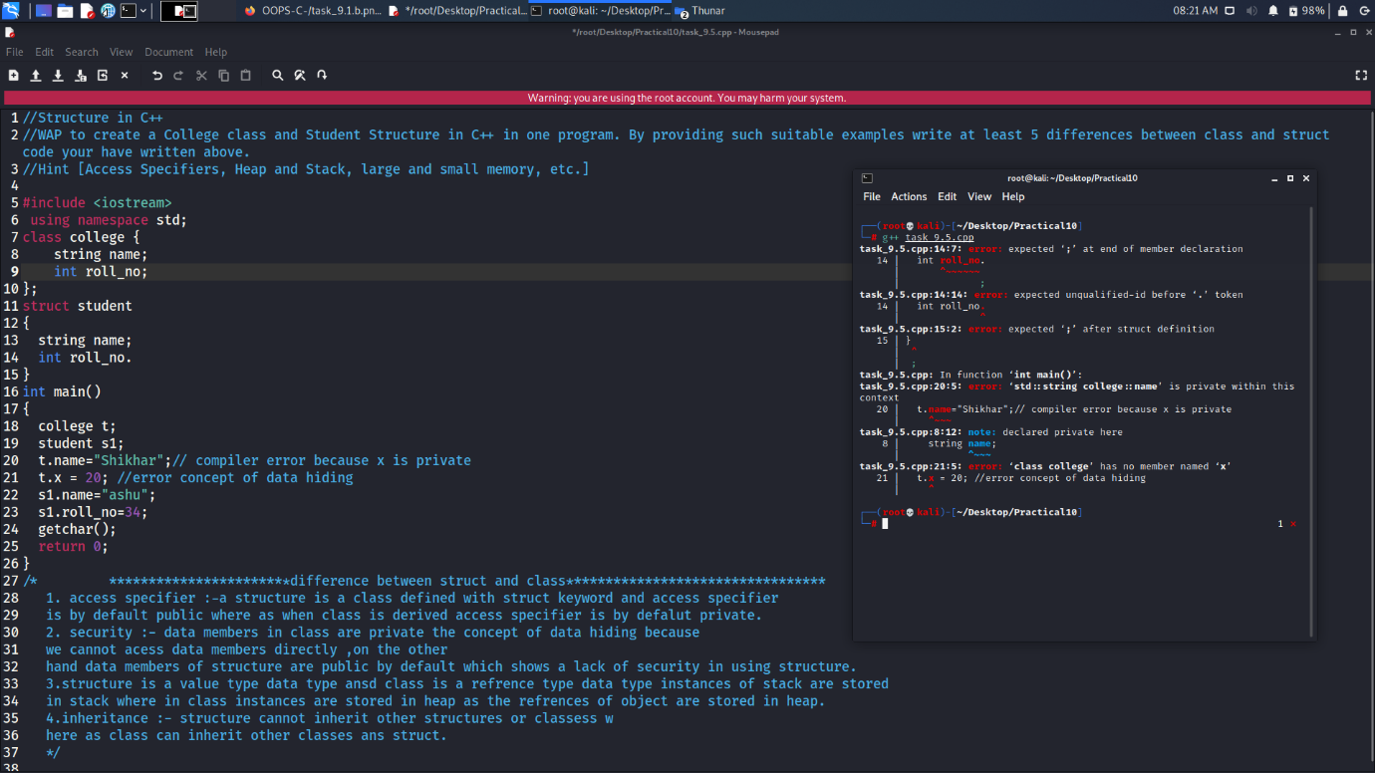

**Program 9**

**Task 6:**

**Source Code:**

#include <iostream>

#include <iomanip>

#include <ios>

using namespace std;

int main()

{

cout << "enter our choice" << endl;

cout << "1.come to next line 2.setting field with 3.fill string with * after setw(15) function" << endl;

int n;

long str = 123456789;

cout << "before before any operation " << str;

while (1){

cout << endl;

cin >> n;

switch (n)

{

case 1: cout << "before going to next line " << str;

cout << endl;

cout << str;

break;

case 2: cout << "after setting field width" << str << endl;

cout << setw(15);

cout << str;

break;

case 3:cout << "before setfill " << str << endl;

cout << setfill('*') << setw(15);

cout << str;

break;

default:

return 0;

}

}

}

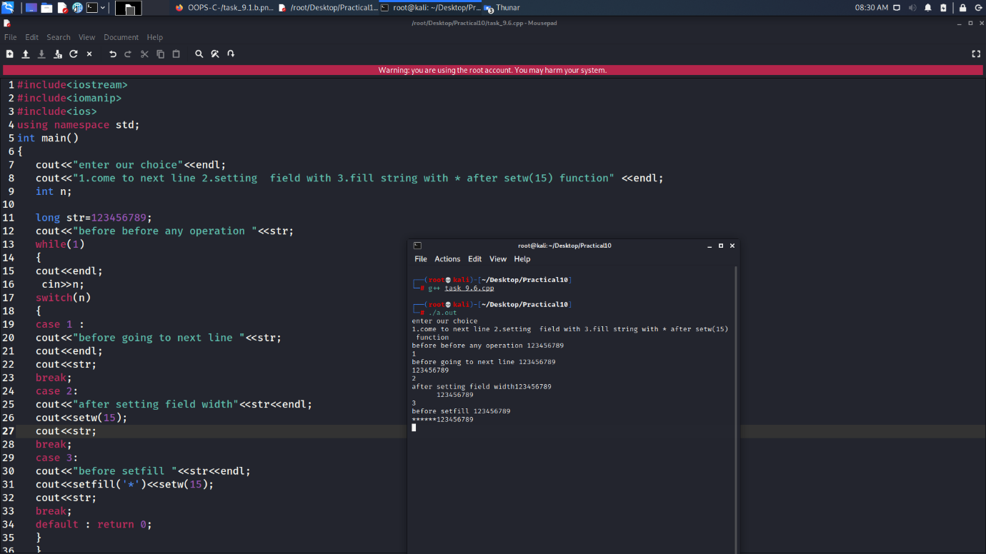

**Program 10**

**Task 2:**

**Source Code:**

#include <iostream>

using namespace std;

class student

{

string name;

string add;

int roll_no;

char sec;

public:

void set_values()

{

getline(cin, name);

getline(cin, add);

cin >> roll_no;

cin >> sec;

}

void show_data()

{

cout << name << " " << add << " " << roll_no << " " << sec;

}

};

int main()

{

student *ptr;

student obj1;

ptr = &obj1;

ptr->set_values();

ptr->show_data();

}

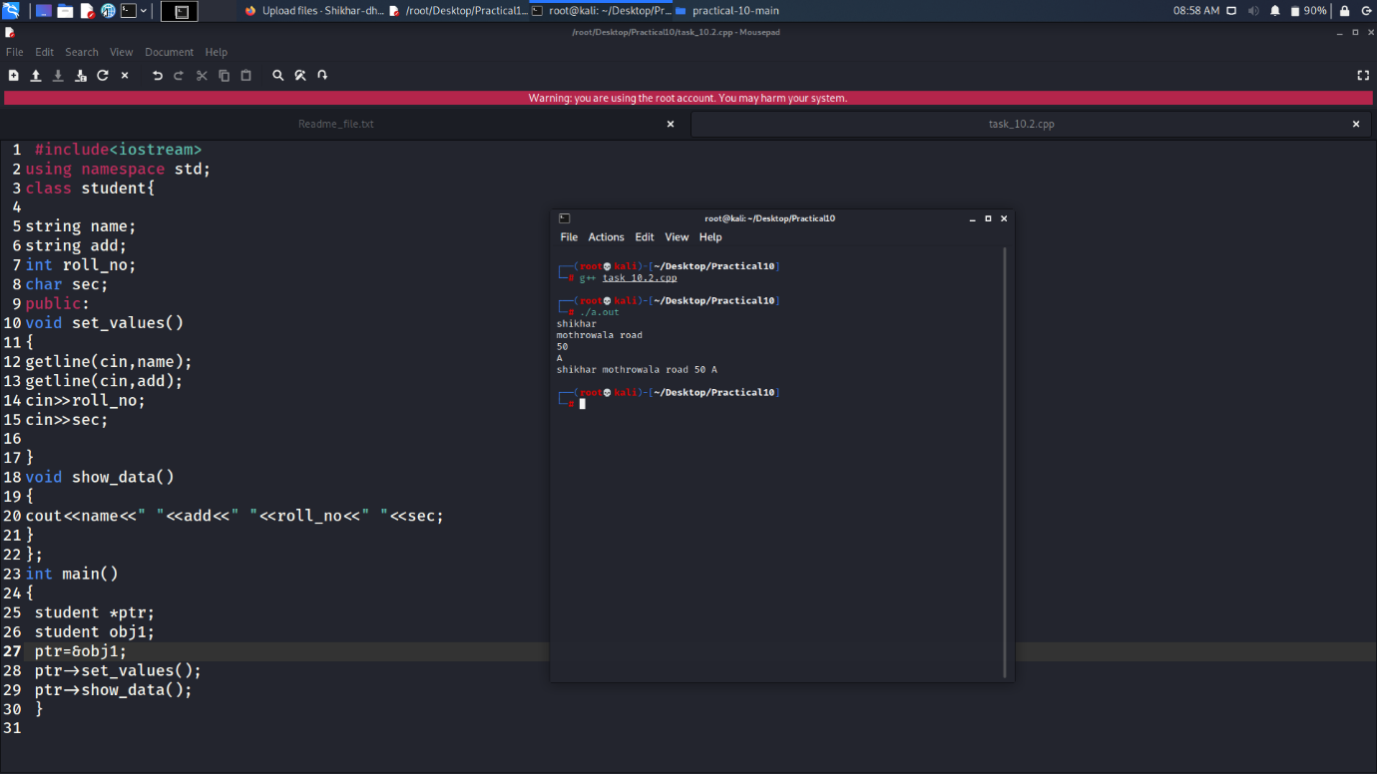

**Program 10**

**Task 3:**

**Source Code:**

#include <iostream>

using namespace std;

class rem

{

int a, b;

public:

rem(int a, int b)

{

this->a = a;

this->b = b;

cout << "remainder of two member variables is " << a % b << endl;

}

};

int main()

{

rem obj(78, 23);

}

**Program 10**

**Task 4 a:**

**Source Code:**

#include <iostream>

using namespace std;

class abc

{

int a;

public:

abc(int a)

{

this->a = a;

}

friend void operator<(abc &obj, abc &obj1);

};

void operator<(abc &obj, abc &obj1)

{

if (obj.a < obj1.a)

cout << "true";

else

cout << "false";

}

int main()

{

abc obj(56);

abc obj1(5);

obj < obj1;

}

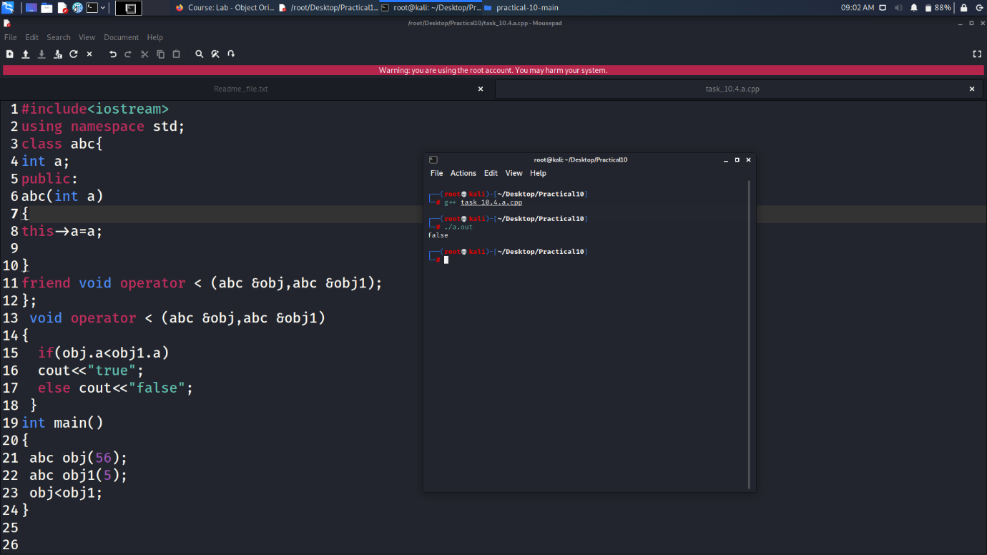

**Program 10**

**Task 4 b:**

**Source Code:**

#include <iostream>

using namespace std;

class abc

{

int num;

public:

abc(int x)

{

this->num = x;

}

void operator+(abc obj)

{

cout << num + obj.num;

}

};

int main()

{

abc obj(10);

abc obj1(20);

obj + obj1;

}

